* indicates a required question

**Proposal Form Section**

\***Proposal Title** (*text entry*):

**Proposal Call** (*automatically filled in based on the call*)

\***Proposal Type** (*select CAT Member*):

\***Primary Area of Research** (*select from dropdown, pick one*):

Biological and life sciences

Chemistry

Earth Sciences

Engineering

Environmental sciences

Instrumentation related to user facilities

Materials science

Medical applications

Optics (excluding x-ray optics)

Physics

Polymers

Purchase of specialty service or materials

Other

**Additional Area(s) of Research** (*can pick multiple*):

Biological and life sciences

Chemistry

Earth Sciences

Engineering

Environmental sciences

Instrumentation related to user facilities

Materials science

Medical applications

Optics (excluding x-ray optics)

Physics

Polymers

Purchase of specialty service or materials

Other

\***Keywords** (can pick multiple from list):

\***Please suggest the most appropriate review panel for your proposal** (*select from dropdown, pick one*):

CAT Member/Resource Staff proposals only

\***Abstract** (text entry maximum 2000 characters, including spaces):

**Collaborator Names**: To be added to an APS proposal (e.g., appear in the search list), a person must be a registered APS user with a badge number and an ORCiD listed in their APS registration record AND have logged into UPS and completed their UPS profile.

*Principal Investigator (PI) (*choose one from list*)

Co-Principal investigator (Co-PI) (*choose one or more from list*)

Co-proposers (*choose one or more from list*)

**Funding Source(s) Section**

\***Funding Sources** (*select one or more from the list below, related questions asked for each selection*):

**Funding Source Details** (*not required but helpful*):

\***Grant Number** (*required for* ♦*certain funding sources, see list*):

\***Percentage** (*total percentages must add up to 100% in order to be able to complete the section*):

|  |
| --- |
| ♦DOE, Office of Basic Energy Sciences (BES) |
| ♦DOE, Office of Biological and Environmental Research (BER) |
| ♦DOE, Office of High Energy Physics (HEP) |
| ♦DOE, Office of Workforce Development |
| ♦DOE, Other (includes LDRD) |
| Foreign |
| ♦Homeland Security |
| Industry |
| ♦National Aeronautics and Space Administration (NASA) |
| ♦National Institutes of Health (NIH) |
| ♦National Nuclear Security Administration (NNSA) |
| ♦National Science Foundation (NSF) |
| Other |
| ♦Other U.S. Government |
| ♦U.S. Department of Agriculture (USDA) |
| ♦U.S. Department of Defense (DOD) |

**Experiment Time Request Section**

**Proposal number** (*pre-filled by the system*)

\***Run Cycle** (*choose one from available/offered dropdown*):

\***1st choice resource** (*choose one from available/offered dropdown*):

\***1st choice instrument** (*choose one from available/offered dropdown, offerings are based on the resource choice*):

\***1st choice technique** (*choose one from available/offered dropdown, offerings are based on the resource choice*):

\***Shifts Requested This ETR** (*text entry*):

**Minimum useful shifts This ETR** (*text entry*):

\***Lifetime Shifts Requested** (*appears on first ETR only*):

(Optional: 2nd choice resource, 2nd choice instrument, 2nd choice technique)

**Additional Questions (for proposal type = APS CAT Member Proposal)**

**General:**

\***CAT Affiliation:** Select from drop down menu

* BIO-CAT
* DCS
* DND-CAT
* GM/CA-XSD
* HPCAT-XSD
* IMCA-CAT
* LRL-CAT
* LS-CAT
* MR-CAT
* NE-CAT
* SER-CAT

**Affiliated institution:** Select from drop down menu

* BIO-CAT affiliated institutions:



* DCS affiliated institutions:

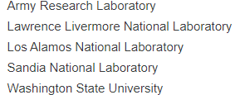

* DND-CAT affiliated institutions:



* GM/CA-XSD affiliated institutions



* HPCAT-XSD affiliated institutions

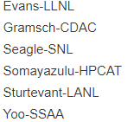

* IMCA-CAT affiliated institutions

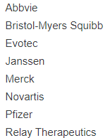

* LRL-CAT affiliated institutions



* LS-CAT affiliated institutions

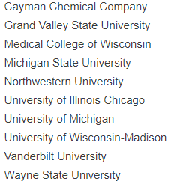

* MR-CAT affiliated institutions

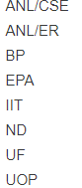

* NE-CAT affiliated institutions

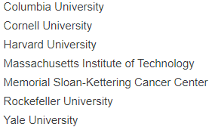

* SER-CAT affiliated institutions

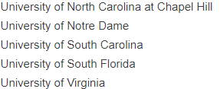

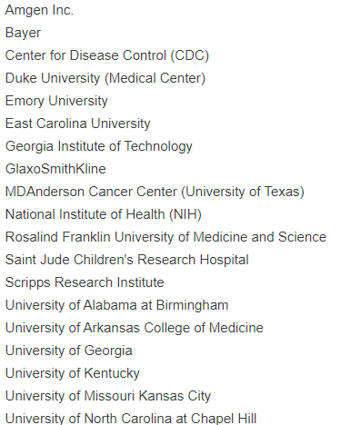

\***Will the data collected be considered proprietary (e.g., work that will not be made available in the open literature)?**

yes

no

\***What mode(s) of access would you consider for this work? (Note: not all beamlines support all modes of access, choose all that apply.)**

Remote

Mail-in

On-site

\***Is this research required for a student's thesis?**

yes

no

\***Is this proposal related to another proposal?**

yes

no

If yes:

\***What changes are being made to this proposal since the previous proposal submission?** (*text entry, 2000 characters* *including spaces*)

\***Please indicate the related proposal number**. (*text entry*)

**Safety:**

\***Does this research involve the use of radioactive samples/materials, sealed sources, or x-ray generating devices?**

yes

no

If yes:

**Please indicate the type of radioactive material involved** (*pick all that apply*):

--samples/materials

--irradiated materials

--sealed sources

--radiation generating devices (RGDs)

\***Does this research involve the use of any of the following** (*pick all that apply*):

--explosives or energetic materials

--a new class 3 or class 4 laser that has not been approved by the Argonne Laser Safety Officer

--nanoparticles (one or more dimensions is 100 nm or less), including thin films, powder, and solutions

--samples/materials that require a BSL-2 (biosafety level) facility

--human subjects or human tissues, body fluids, or cells in culture

--plant pathogens, soil microbes, animals, insects, or insect/animal tissues, body fluids, matter, cells in culture

--none

**APS Experiment Time Request (ETR) Questions**

**If you will require use of laboratory space during the requested scheduling period, provide details here**. (*text entry, 2000 characters* *including spaces*)

\***Will you be bringing any electrical or hazardous equipment to the facility during this scheduling period?**

yes

no

If yes:

\***Please describe the equipment and its intended use**. (*text entry, 2000 characters* *including spaces*)

\***Would the work associated with this request for time involve any of the following (choose all that apply):**

* Pure gases (or single gas component) greater than 1.3 ft3, 36 L or 1 lb. (inert gasses excluded)
* Liquids greater than 5 gal. or 19 L
* Solids greater than 18.1 kg or 40 lbs.
* None of these apply

**Preferred experiment dates for this request, enter date span(s) in format MM/DD/YYYY.**

**Unacceptable experiment dates for this request, enter date span(s) in format MM/DD/YYYY.**

**Export Control Follow on ETR question (for ETR #s 2 or later only)**

\***By submitting this Experiment Time Request (ETR), I certify that the funding sponsor, proposal scope, and/or research samples/specimens have not changed since the original proposal was submitted.**

yes

no

If no:

**If you answered "no" to the prior question, please describe the change(s).** (*text entry, 2000 characters* *including spaces*)

**Export Control/S&T Matrix Research Screening Questions**

1. \***Are there any restrictions, contractually or otherwise, on public dissemination of the work (e.g., research, experiment) described in this proposal? Public dissemination includes presenting at conferences or open meetings, publications, or web source information**.

yes

no

1. \***Are you bringing any items (including specimens/samples), technical data, software, or services owned or funded by a nuclear, defense, military, space, intelligence agency, or a defense contractor of the United States or of another country?**

yes

no

1. \***For work (e.g., research, experiment) conducted at the user facility, are any items, technical data, software or services designed, developed, or modified exclusively for military applications, military training, spacecraft, launch vehicles, or national security or intelligence collection and analysis?**

yes

no

1. \***Would the research results be directly useful for- or would the research involve- a nuclear reactor application (e.g., commercial nuclear fuel, molten salts or other nuclear reactors, nuclear grade graphite, uranium enrichment)?**

yes

no

1. \***Are you bringing any items (including specimens/samples), technical data, or software to the user facility that require restricted access?**

yes

no

6) \***For DOE National Lab PIs or employees, please affirm that your research has been screened by your National Lab against the DOE “Science and Technology Risk Matrix” critical and emerging research areas and technologies. Note: If no or unsure, you should contact your home institution’s office responsible for screening research for the DOE S&T Risk Matrix. The User Facility must be consulted to determine if research restrictions can be accommodated.**

Yes, I affirm my work has been screened

No, my work has not been screened

I am not a DOE national lab PI or employee