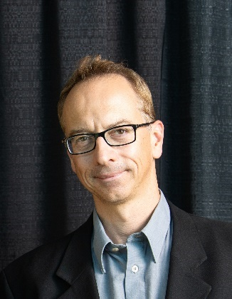
Tamas Varga
tamas.varga@pnnl.gov

https://www.emsl.pnnl.gov/staff/tamas-varga

Current Position
- Materials Scientist, Team Lead, Environmental Molecular Sciences Laboratory (EMSL), Earth and Biological Sciences Directorate, Pacific Northwest National Laboratory (PNNL), Richland, WA

Education & Employment History
- Materials Scientist, EMSL, PNNL (2009-present)
- Postdoctoral Appointee, Argonne National Laboratory (2007-2009)
- Postdoctoral Scholar, University of California, Davis (2005-2007)
- Ph.D. Chemistry, Georgia Institute of Technology, Atlanta, GA (2000-2005)
- Quality Assurance Officer, TEVA Pharmaceutical Industries Ltd, Debrecen, Hungary (1999-2000)
- M.S. Economics, University of Miskolc, Miskolc, Hungary (1997-1999)
- Technologist, TVK Plc. (Member of MOL Group), Tiszaújváros, Hungary (1995-1999)
- M.S. Chemistry, University of Debrecen, Debrecen, Hungary (1990-1995)

Honors & Activities
- Advanced Light Source (ALS) UEC Member (2023-present)
- Selected for Advancing Manager Pathway, 2-year cohort training program, PNNL
- Lead for SOILARIUM, an eBERlight-MONet collaboration between APS and EMSL
- Co-organizer/chair of ALS Earth and Environmental Sciences Visioning Workshop (2023)

Interests
- X-ray imaging and spectroscopy techniques, and their application to the environmental and materials sciences
- Environmental biogeochemistry, mineral-organic interactions in soil
- User facilities, user support, collaboration between user facilities
- Multimodal structural and chemical imaging, data integration for models, automation

Ideas for Advocacy for the User Community
As a user support scientist at EMSL, and a long-time user of synchrotron user facilities, I believe that I can contribute to the mission of the UEC. Specifically, I would like to help promote collaboration between user facilities such as EMSL and APS and enable dialogue between biological and environmental researchers and the synchrotron community, especially beamline scientists. I believe that the instruments available at the APS can play an even greater role in the Biological and Environmental Research (BER) science, and I would like to work on making the APS beamlines known and accessible to an even wider user base. I would also like to promote the introduction of synchrotron techniques to a wider student audience.

