APS Work Project Checklist
  - Create project checklist with automated routing
This application is an electronic version of the Work Project Checklist, incorporating the function of the Work Entry Clearance and allow for electronic routing and approvals.

Access Requirements
To access the system, you will need a browser, ANL credentials and APS Coordinator role. You also must be inside the APS network. The URL address is:
https://beam.aps.anl.gov/pls/apex/f?p=WORKPROJCHK
Enter your ANL credentials when prompted:
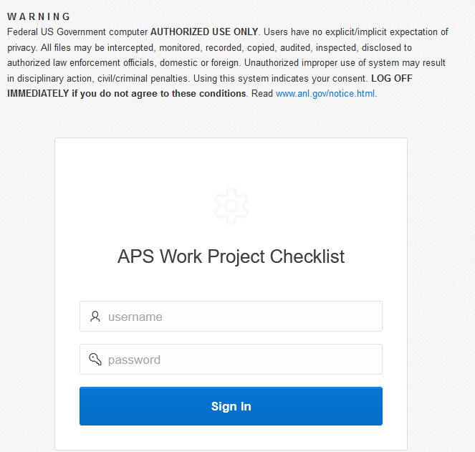
To obtain the APS Coordinator role, contact Steve Bogdan at sbogdan@anl.gov.

Creating a checklist
After logging in, click Add a Checklist
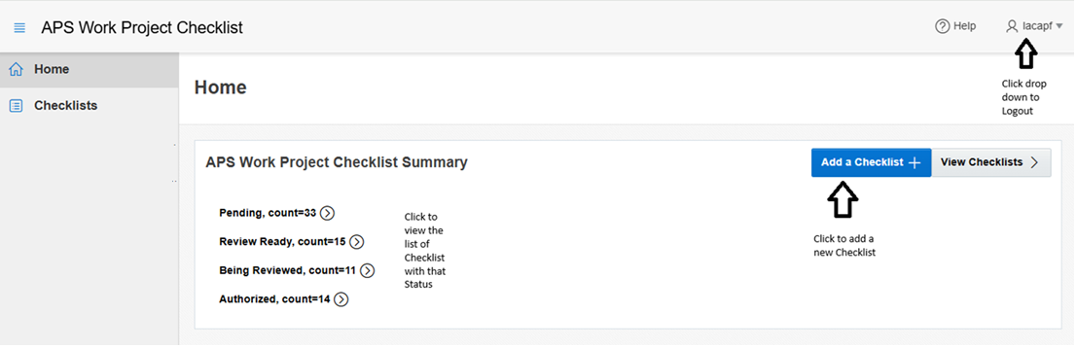

Please refer to a separate document “Instructions for Completing the APS Work Project Checklist” that can be found in ICMS: https://icmsdocs.aps.anl.gov/docs/groups/aps/documents/other/aps_2037274.pdf
https://icmsdocs.aps.anl.gov/docs/groups/aps/documents/form/aps_1259683.pdf

The checklist entry form is divided into various sections. Fields with a red asterisks(*) are required fields. Names of persons can be free form, auto-populated from the Workday database or from a pre-specified drop-down list.
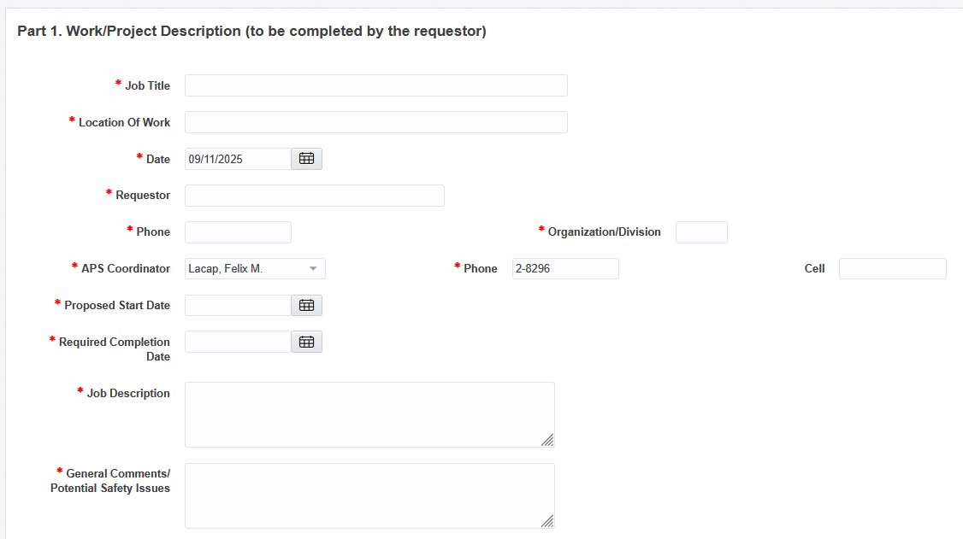
Radio buttons contain “Reset” to remove previously selected values. Checkboxes allow for one or more selections.
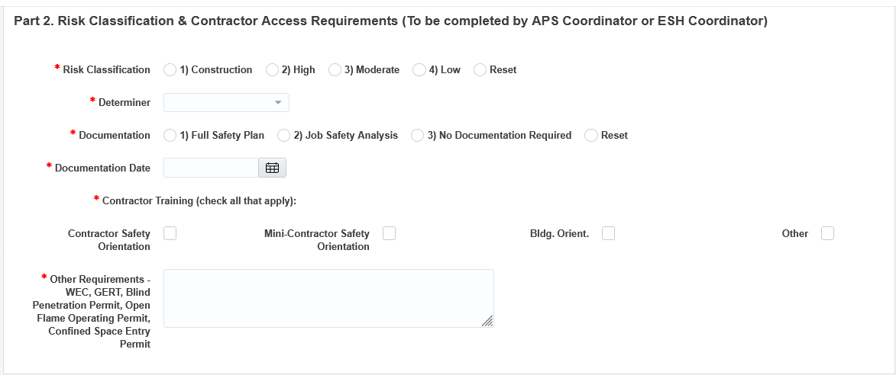
Reviewers/approvers are selected by first checking the “Y” radio button and then selecting Designates. Alternates are optional. Note that these selection will generate the routing list when the checklist is saved and submitted for review.
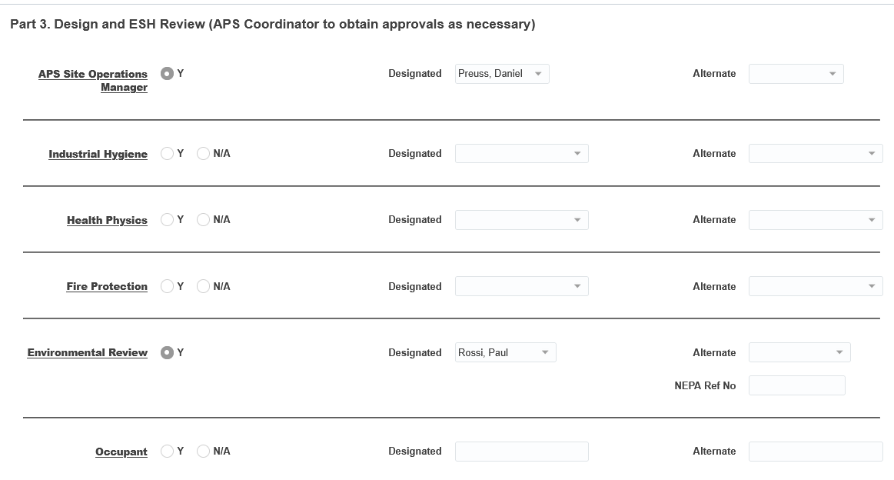
Up to five “Other” approver line items may be added to the list
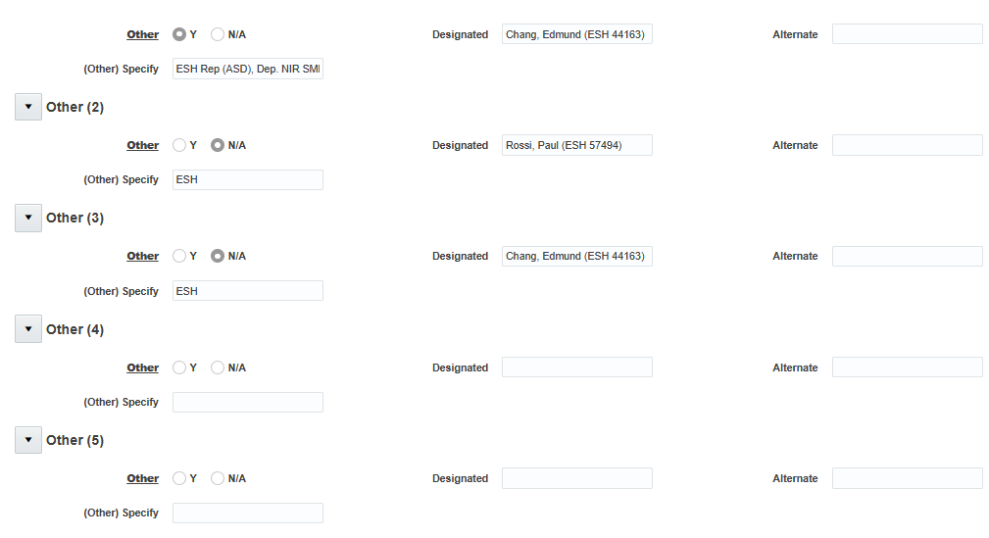
Project management information may be filled in at anytime during the entry process.
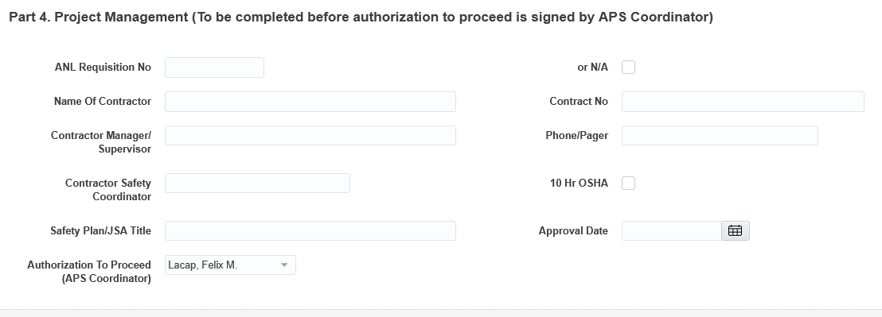

Files can be attached to the checklist once it has been saved to the system
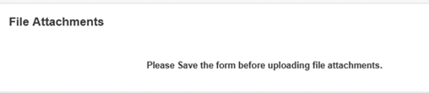
Choose a file from your local drive when prompted. Files must either be in PDF or Word format and need to be under 15MB in size
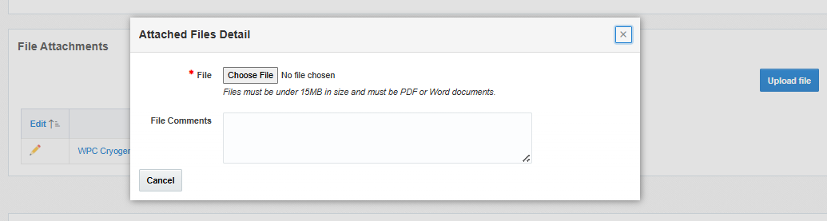

Checklist Status
The checklist status is indicated on top of the form.
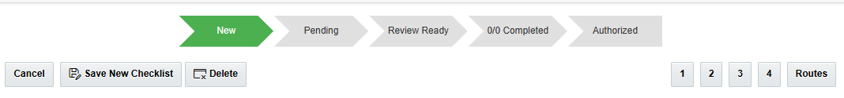
When a checklist is saved the first time, a unique identifier is generated and displayed on the upper right hand of the form. This identifier is based on the calendar year the checklist was created, the requester’s division and a sequence number. Also note, the status is updated from New to Pending
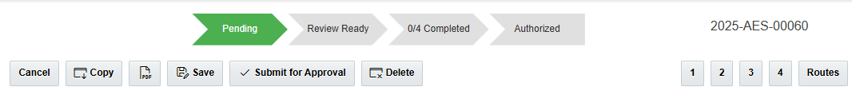

After all the required fields have been entered, the checklist is then submitted for approval and the status moves to Review Ready.
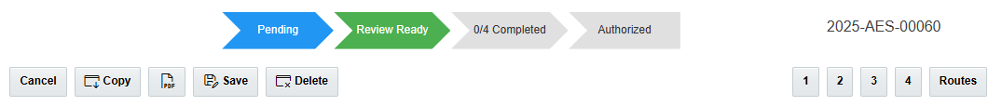

Approval Routing Requests
Approval routing request emails are generated as soon as the checklist status is Review Ready. The routes are based on the persons assigned in Part 3 of the form. Sample route list is below.
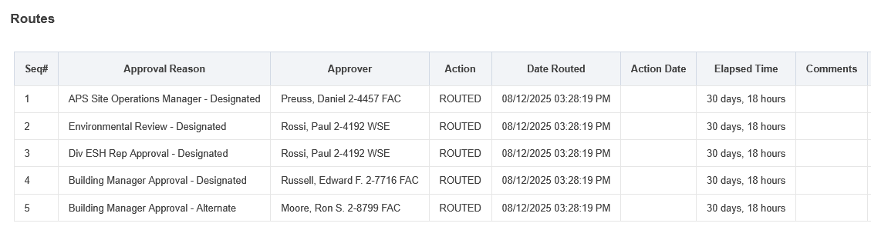
When everyone in the list have approved, the checklist status becomes Authorized.
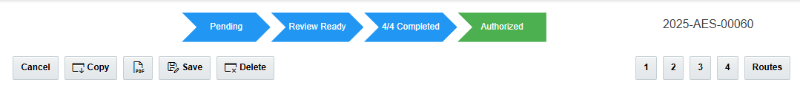

Querying for Checklists
You can query checklists for different status and/or by different APS coordinators. Click the Checklist on the left menu. Select Status and/or APS Coordinator and click Go.

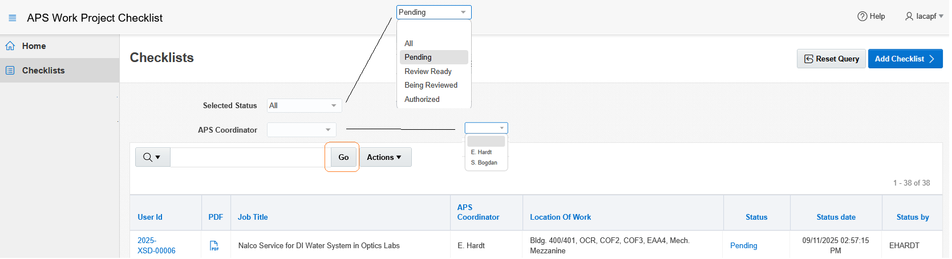

Generate the checklist PDF
Click the PDF icon to generate the checklist PDF.
From the Query Listing:
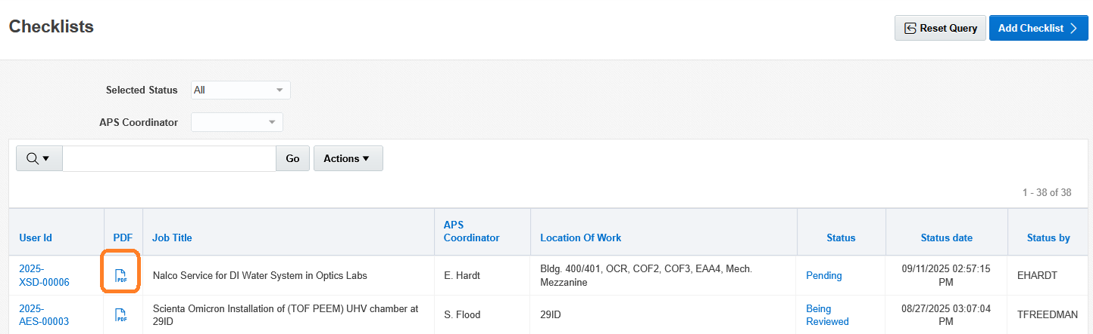

From the checklist form:

Sample PDF is shown below:
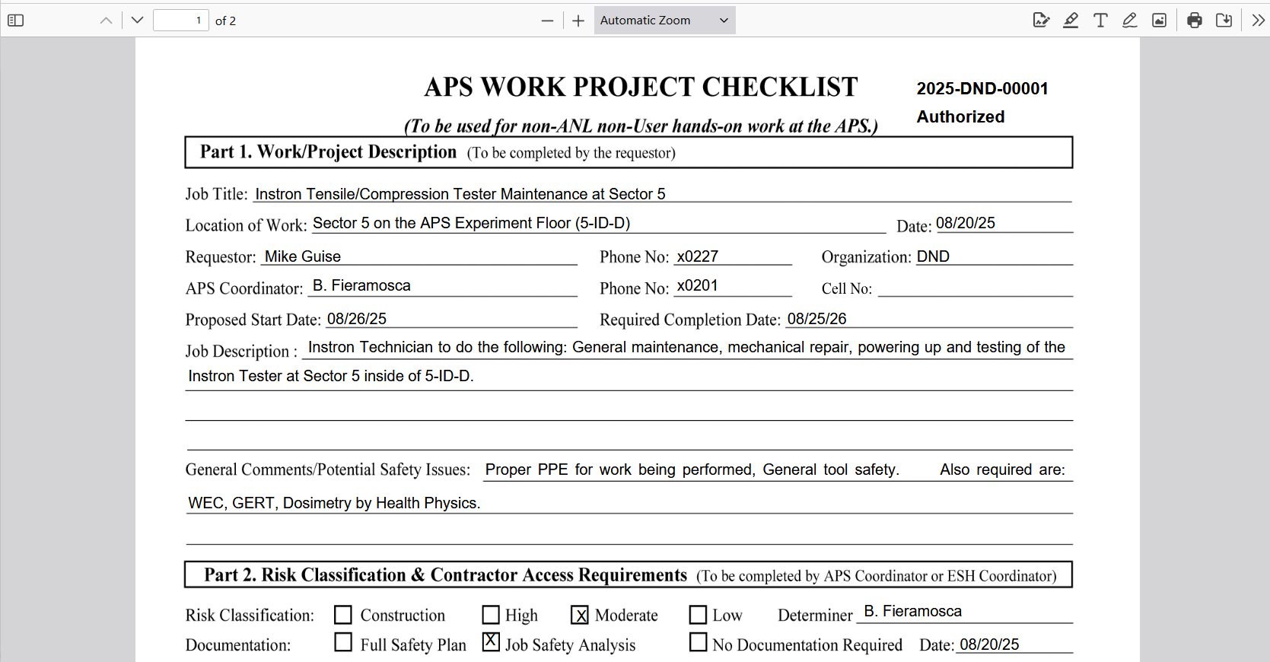

Other Features
Ability to Delete – Click the Delete button to delete a checklist regardless of status. There is Undelete button to reverse the action. Note that the checklist is not physically deleted but a delete flag is updated.
Ability to Copy – Click the Copy button to copy a checklist to a new one. The parent ID is stored with the newly copied checklist.
Ability to Archive – this feature is still to be determined and implemented.

