Present: Wendy, Liz S., Bruno, Liz H., Ashley, Clay, Steve, Bruce

FC Shift Presence: 10/10/22- 10/30/22
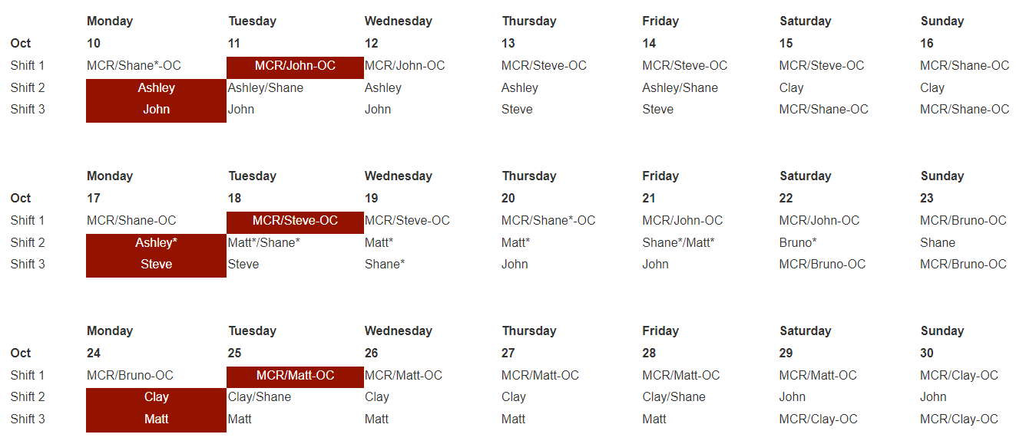
Vacation/DORs

Nena Moonier - 10/18 (½ day- afternoon)
John Mazzio - 10/17 -10/19
Shane Flood - 10/17

Events from Last Week
- 28 reported squeaky hutch door on B station. MOM-VAC checked it out on Monday. May need to adjust maintenance schedule for new doors (lubrication fixed the issue).
  - Per Ashley: rail was lubricated today (10/17) and issue is resolved

Safety Share

- Matt S. - Oversight of beamlines moving large items on pallet jacks. See 9/19 turnover notes for more detail
- John M. - Lead cleanup: IH has requested that if the FCs are going to do cleanup that they get specific training to do so: Mike Fries is working on a WCD to encompass FCs in lead cleanup responsibilities
- John M - Several fire extinguishers were found to not have been inspected in many years. Working with ANL Fire Department on creating list of fire extinguishers in cages around the ring.
- Shane F. - 25-ID: moved large laser table; long stringers are a two-piece design and were lifting the table at the weakest point; do not assume that rigging is moving an item correctly; speak up if you feel a task is not being done correctly
- Clay W. - Work Requests: do not be afraid to edit work requests so that the scope of work is accurately captured.
- Clay W. - DEEI inspections of equipment are not enough for an experiment to proceed. Should also look at the whole setup from an electrical standpoint and may require a DEEI to look over set up

Experiments of Note

10/17/2022 - 10/24/2022

- ESAF 262517 at 16-BM-D. Onsite users from LLNL. 10/18/22 - 10/21/22. Radioactive Materials
- ESAF 262392 at 13-BM-D. Onsite users from Washington State. 10/18/22 - 10/19/22. Radioactive Materials
- ESAF 262393 at 16-ID-D. Onsite users from Notre Dame. 10/19/22 - 10/20/22. Radioactive Materials
- ESAF 262859 at 10-BM-B. Onsite users from LANL. 10/21/22 - 10/24/22. Radioactive Samples
- ESAF 262817 at 16-ID-B. Onsite users from LLNL. 10/21/22 - 10/24/22. Radioactive Samples
- ESAF 262177 at 35-ID-B. Onsite users from LLNL. 10/22/22 - 10/30/22. Energetic Materials
- ESAF 262963 at L3120 (Sector 16 401 lab). Onsite users from LANL. 10/22/22 - 10/30/22. Energetic Materials

Round Table Discussion

Nena
- Reminder: FC Day shift hours: 8:30am to 5pm when not on shift
- Performance Appraisals: AES normalization meetings completed last week. Supervisor input by 11/3
  - Employee goals will discuss at next EFOG meeting
- AES All Hands meeting Oct 19, 2022 at 1pm
- Lab Wide All Hands Meeting Nov 1, 2022 at 10am
- Training: Check your training profile. Several people are expired in courses.
- Group picture – Monday, Oct 24 at 3pm

Upcoming Learning Opportunities

- Leadership Institute Quarterly Forum: How do we build strong collaboration skills to support learning and innovation. Employee forum Tuesday Oct 18 from 10 to 1130am
- ESH417 QEW Cord and Plug Electrical Safety Training 10/11 8am to 11am register via TMS
- ESH414 Electrical Safety Training for QEW1 10/11-12 1 to 5pm register via TMS
- WPC 203 workshop: Human Factors: A team Approach: 10/26 8:30 to 10:30 register via TMS
- Voice of PSC: Thursday, Oct 20 1pm (speaker: Professor Talat Rahman)
- OPEN HOUSE: May 20, 2023
- Tour of 981: Mark Erdman and Ralph Bechtold will conduct tours every week on Tuesday and Thursday from 4pm to 5pm. Sign up here:
- Argonne 1 hour campus bus tour: depart from Bldg 201: 10/20 at 12:15 11/16 at 9:30am and 10:45am and 12/14 at 1pm and 2:15pm. Sign up here
Liz S.
- Nothing further at this time
Bruce
- Current ESAF Vector requests for Jennifer:
  - Split Sector 20 into 20-BM and 20-ID in the ESAF system admin.
  - Restrict User_type = “Beamline Staff” to APS employees and Resident Users.
  - Add copies of the POC and Host fields (on the Beamline Admin tab) to the Comment Summary tab. Add the Host Name field to the ESAF EA form.
  - Restrict users on ESAF to valid site access.
  - First part of ESAF update #6 is completed. Beamline Staff role can only be APS employee or resident user. Entered a new request to complete the other parts of the original request.
- Looking at ESAFs.
Bruno
- 3-ID-C having 2 outlet strips installed on the internal inboard wall.
Targeting to finish by the end of Oct. 2022. Scheck is waiting for parts to complete this work.
- Sector 5 ongoing work for Gas Cabinet Transfer Lines Rerouting.
Targeting to finish on Nov. 14/15 two-day Machine Studies to avoid hutch roofs during The Run.
The Work Request is approved and the SOW has been detailed in anticipation of the start of work.
- 5-BM-B acquiring estimate to install a 480V outlet and related switch for The Upgrade.
Ongoing.
- 5-BM-A to have very large beam flight path removed by Rigging Crew for The Upgrade.
Riggers will be waiting for other 5-BM-A equipment to be moved before removing the flight path.
- KEEP IN MIND: Due to frequent LN2 venting, the following station mounted ODH monitors may alarm on a regular basis: 10ID-A, 21ID-D, 4ID-B (alarms cannot be silenced).
- 4 portable O₂ monitors: Portable O2 monitors have been issued to several experimental stations. Please be aware that O2 monitors are at 3-ID-A, 4IDD, 20IDA, 25IDB.
- Besides 432, Bruno will be the 431 area Floor Coordinator until further notice. Which includes the 431 LSIs, LOTO board inspections and 431 eyewashes. Beamline staff were notified of this from 1-BM through 4-ID.
- Working with Robert Winarski and the MOM group as there will be a lot of relocation and new installation of oxygen deficiency monitors and ozone monitors due to the Upgrade.
- I’m in the process of purchasing a diverse, up-to-date inventory of handheld gas monitors.
  - 10-ID-B (UOP) purchasing their own multi-gas hand-held monitor which will need calibration.
- All 13 RKI wall mounted monitors have had their sensor units removed and have been hand delivered to the vendor for calibration as of today. All units will be returned, in short order, this week and reinstalled in their respective beamlines.
- Sector 15 shop area band saw was locked out some time ago for a burning smell. Cari Helberg inspected the band saw on 10-10-22. On 10-14-22 per T. Smith (EFOG) and E. Zoellner (15-ID) I removed the power cord, clam-shell, LOTO device on the band-saw inside of the Sector 15 cage. The reason for LOTO removal was to accommodate T. Smith in completing an electrical inspection after modifications were done to remove the welder from the band saw. T. Smith completed the electrical inspection, however, I reapplied the LOTO until a new set of metal covers are built and installed over the opening of the old welder.
Clay
- Construction of Sector 8 & 9 on schedule for Fall:
  - Most power down in 8ID. Meade Electric on site beginning today or tomorrow for removal of electrical infrastructure. Water LOTOed by MOM today.
  - Power down in 9ID, ready for Meade
  - LOTO of air, N2, HVAC, and fire suppression to take place at both 8ID and 9ID over the next week
  - Vital element of electrical LOTO and demo is the requirement that any electrical worker MUST re-verify zero energy with a tic tracer at the point of disassembly or line cut before taking action. This final verification is in addition to the panel/circuit ZVV requirement under LOTO procedure.
  - 8BM: No change. Scheck to begin partial disentangling of 8BM/8ID electrical service today. A and B stations remain APS Disabled.
  - 9-BM welding complete. Door to floor clips, the last detail for Scheck, anchored today. Type C some time this week, dependent upon BL staff availability.
- Grinding SR wall at 11-BM-A : No change.
- 11-ID-D laser transport moved and reassembled. CCWP still open.
- Large Scale Power Shutdown in January 2023; details to TBD. Ramifications of the power loss are considerable, and last week’s meeting was an “eye opener”. Details unknown, and a possible solution (low probability but not zero) is to delay the work until the dark period. No notifications to the experiment floor until firm, actionable information is available. For now? All is speculation
- Clay to add info on labyrinth harvesting
John
- Routine Rad Survey this week at 18-ID on Tuesday at 2:30pm
- Matt will clean out the cabinets this Friday and Monday
- Taking over Rick Spence’s responsibilities for storage in Building 364. Limited availability through November 30th. Open to APS staff from December 1st until road construction starts. Met with construction project manager; nothing to go up the ramp that is heavier than a pickup. Need to schedule moving items out of 364. February/early March.; Construction presumed to take 3-4 months. Check with John through November 30th to schedule accessibility.
- End dates on ESAF: should we be asking if they are correct. Reminder on EA checklist to verify the end date and if it's different to make a note on the EA form in the cabinet.
Matt
- Out sick last week, nothing new to report
- Will close out CCWP at 9BM for door welding once work can be compared to SOW
Ashley
- Scheck BPA SOW/WPC Updates:
  - Processed: 433/434 gas yard camera installation (SOW completed). Concrete cutting for door trench extension at 19ID-E (still waiting on full approval for both)
  - Upcoming: LTHW piping reroute for 20ID-E hutch
- Reminder: I am one of the AES DEI reps. If anyone has anything DEI related they want to talk about, please get in touch. This can include issue, improvements, or ideas for DEI events/participation for new PA requirement.
Shane
Steve
- Steve is scheduling DEEIs.
Wendy
- If beamlines have scrap metal, wires (copper) or small amounts of lead that they want to get rid of please let me know.
- 4 dumpsters will arrive in the 433-parking lot this Thursday and Friday (10/20-21) for the start of beamline station panel recycling (will be loaded by Caratelli, starting at 8ID and 9ID)
- Discuss resurveying at 25-ID
Liz H.
- If something interesting is happening in your area, would like to shadow
- Upcoming in-person trainings:
  - 10/18: CPR/AED and Rad Worker 1 Practical
  - 11/1: Workplace Violence
  - 11/10: WPC Microlearning
  - 11/17: Work Planning and Execution Workshop

EFOG POC List

- EFOG POC - Roadwork schedule and impact – Clay White
- EFOG POC - APSU Scheck BPA Fixed Price; SOW, WPC - Ashley Wayman
- EFOG POC - 8-ID/9-ID Decommissioning - Clay White
- EFOC POC- 9-BM Job Coordinator-Clay White, FC-Matt Spilker, CCSM Wendy VanWingeren
- EFOG POC - Sector 20 move out and move in - Matt Spilker
- EFOG POC - LBB – Ashley Wayman, Matt Spilker
- EFOG POC - Beamline metal/etc. recycling program - Wendy VanWingeren
- EFOG POC - Building Operations Team - Matt Spilker

