Present: Nena, Wendy, Liz S., John, Steve, Bruce, Shane, Liz H., Matt, Bruno, Clay

FC Shift Presence: 10/3/22- 10/30/22

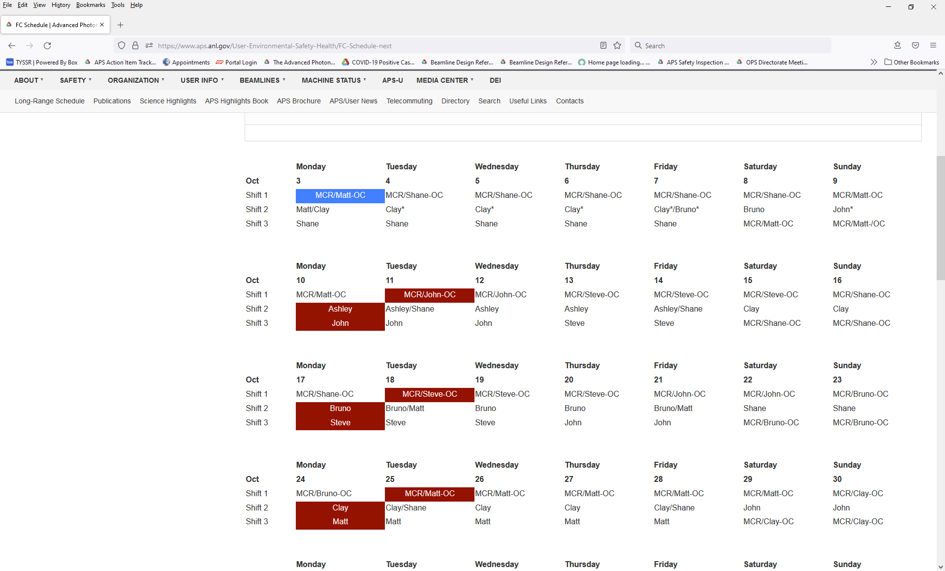

Vacation/DORs:
Bruno Fieramosca – 10/5 and 10/6
Ashley Wayman - 9/27 - 10/7
Clay White – 10/6 and 10/7
Matt Spilker – 10/6 and 10/7

EFOG-POC Ongoing list:
- EFOG POC-Roadwork schedule and impact–Clay White
- EFOG POC-APSU BPA Fixed Price Scheck: SOW, WPC-Ashley Wayman
- EFOG POC-8-ID/9-ID Decommissioning: Clay White
- EFOG POC-Sector 20 move out and move in: Matt Spilker
- EFOG POC-LBB –Ashley Wayman, Matt Spilker
- EFOG POC-Beamline metal/etc. recycling program-Wendy VanWingeren
- EFPG POC-Building Operations Team-Matt Spilker

Events from Last Week
- 27-ID Studies: 3-5pm 10/1. Not aware that shutter enable will be given
  - Matt came in to disable all A stations except 27ID and 35BM
- 10/1-10/3 (8am) Studies. Beamlines were not aware that FC was not present over the weekend
  - Future. Email sent the Friday before to warn beamlines

Experiments of Note:

10/3/2022 - 10/10/2022

- ESAF 261010 at 16-BM-D. Onsite users from LLNL. 10/03/22 - 10/06/22. Radioactive Materials
- ESAF 261421 at 16-ID-D. Onsite users from LLNL. 10/05/22 - 10/07/22. Radioactive Materials

Round Table Discussion

Nena
- Covid guidance
  - Updated APS web info: https://www.aps.anl.gov/Users-Information/Updates/Covid-Rule-Regulations
- ESAF rules for submission and approval: No Rules
- Reminder: FC Day shift hours: 8:30am to 5pm when not on shift.
- Performance Appraisals: Supervisor input and normalization meetings
- AES All Hands meeting Oct 19, 2022 at 1pm
- Training: Check your training profile. Several people are expired in courses.
- Oversight of beamlines moving large items on pallet jacks. See 9/19 turnover notes for more detail
- New FC-Elizabeth Hardt: What accounts are left for her to have access to?
- Group picture- Monday Oct 24 at 3pm.
- Mike Fries will be out of the office 10/6 to 10/16. Contact Paul Rossi for any items that need attention.
- Contact Tim Ortiz for training items (TMS) in lieu of sending to Sue Benda.
Liz S.
- Beamlines that still need to post a commissioning ESAF for 2022-3 as noted in Shift Log:2-BM, 4-ID-E
  - Reminder 35-BM operates under a BOA; no commissioning ESAF required for 35-BM
- ESAF comments have been updated; GFCI comment removed per Paul Rossi
Bruce
- Current ESAF Vector requests for Jennifer:
  - Split Sector 20 into 20-BM and 20-ID in the ESAF system admin.
  - Restrict User_type = “Beamline Staff” to APS employees and Resident Users.
  - Add copies of the POC and Host fields (on the Beamline Admin tab) to the Comment Summary tab. Add the Host Name field to the ESAF EA form.
  - Restrict users on ESAF to valid site access:
- Looking at ESAFs.
Bruno
- 3-ID-C having 2 outlet strips installed on the internal inboard wall.
Targeting to finish by the end of Oct. 2022. Job estimate has not been worked out yet.
- Sector 5 ongoing work for Gas Cabinet Transfer Lines Rerouting.
Targeting to finish on Nov. 14/15 two-day Machine Studies to avoid hutch roofs during The Run.
- 5-BM-B acquiring estimate to install a 480V outlet and related switch for The Upgrade.
Ongoing.
- 5-BM-A to have very large beam flight path removed by Rigging Crew for The Upgrade.
Riggers will be waiting for other 5-BM-A equipment to be moved before removing the flight path.
- KEEP IN MIND: Due to frequent LN2 venting, the following station mounted ODH monitors may alarm on a regular basis: 10ID-A, 21ID-D, 4ID-B (alarms cannot be silenced).
- 3 portable O₂ monitors: Portable O2 monitors have been issued to several experimental stations. Please be aware that O2 monitors are at 3-ID-B, 4IDD, 20IDA, 25IDB.
- Besides 432, Bruno will be the 431 area Floor Coordinator until further notice. Which includes the 431 LSIs, LOTO board inspections and 431 eyewashes. Beamline staff were notified of this from 1-BM through 4-ID.
- Coherent Laser coming onsite on October 3rd; WPC-JSA will be on Bruno’s door.
- Working with Robert Winarski and the MOM group as there will be a lot of movement of oxygen deficiency monitors for the Upgrade.
- I’m in the process of purchasing a diverse, up-to-date inventory of handheld gas monitors.
  - 10-ID-B (UOP) purchasing their own multi-gas hand-held monitor which will need calibration.
- Band saw at 15 shop area was locked out some time ago (burning smell); Eric Zoellner is waiting for permission to remove welder from band saw
- Will post AR for 8-BM
Clay
- Construction of Sector 8 & 9 on schedule for Fall:
  - Power will go down in 8ID late this week, and Meade Electric will begin removal of electrical infrastructure. Cable trays will start coming down tomorrow.
  - The fate of 8-BM is still unknown, but the beamline will not run in September. Both A and B stations are APS Disabled.
  - 9-BM will not run until after the dark period.
  - Welding the inboard door of 9BM-C has been pushed back several days, and is now scheduled for October 12th.
- Future work: Grinding SR wall at 11-BM-A past conceptual design review, contractor has visited and provided estimates. Still in review phase and moving forward.
- Bluff Road work from access road to infield and back to 432/water tower; entire section deferred to FY24 or later
- 431 later this week LOTO at load frame device at Sector 1; FAC will do the lockout and Roger will complete the work; Mike Fries has completed the WCD; 1st repair attempt was unsuccessful
- Thursday laser transport at 11-ID-D will be dissembled and reassembled at 25-ID-E
- Most likely Friday LOTO on panel inside 20-ID-B; swap out breaker for one that is less sensitive to rapid spikes
- Work Requests: do not be afraid to edit work requests so that the scope of work is accurately captured
- During upgrade regular Survey & Alignment and Riggers will be available
- When we go dark; 1st priority is LOTO and the 2nd is removing everything from the storage ring through the super doors (anticipated to take 3 or 4 or more weeks)
John
- Routine Rad Surveys at 7ID (Wed) and 5ID (Thur)
- Mike Fries is working on a WCD to encompass FCs in lead cleanup responsibilities.
- Working with ANL Fire Department on creating list of fire extinguishers in cages around the ring. Many have not been inspected in many years due to being locked up.
- Taking over Rick Spence’s responsibilities for storage in Building 364. Limited availability through November 30th. Open to APS staff from December 1st until road construction starts in late. Met with construction project manager; nothing to go up the ramp that is heavier than a pickup. Need to schedule moving items out of 364. February/early March.; Construction presumed to take 3-4 months. Check with John through November 30th to schedule accessibility.
- Nena to touch base with Randy about tunnel searches and who can perform those searches.
Matt
- Assisting Rick Spence with the move from 11-ID-D to 25-ID-E.
- Thursday morning: many low water faults; there was also a power sag issue
  - 6 and 7 due to main water pump failure; switched to secondary pump
  - Matt reset PSS trips at 6 and 7
  - Not sure why there were flow faults at 8 and 9; could not reset the faults here but this equipment is no longer in place
Ashley
- Scheck BPA SOW/WPC Updates:
  - Processing: None
  - Upcoming: 433/434 gas yard camera installation (SOW completed).
- Vacation 9/27 - 10/7. Wendy will be a backup for the Scheck BPA WPCs.
- Proc Project Update-Fully Approved Procs:
  - Use of the APS Enable Key (APS_1251334)-combo of APS Enable Removal when Posting a CCWP and APS Enable Removal at the End of User Operations and Reinstating Enable at the Start of User Operations.
  - Locking an Experiment Station Containing Hazardous Materials or Conditions (APS_1254023)-combo of Locking an Experiment Station under an Administrative Restriction and Locking an Experiment Station Containing Hazardous Materials
- 12ID Type C? - Clay will convert to an AR
- Green eyewash station by machine shops-when will they get liquid? - the liquid is in Clay’s office but it is in question as to who will maintain this
- Have requested locks for staff moving into new offices in 436B corridor on the way to LBB
- What will happen to RSS tags during the dark period? Minor upgrades and do no harm – CCWP process; all feature beamlines and BMs will be decommissioned; may have to review specific projects at specific beamlines
- You can no longer change accounts in ICMS; work around is to completely close out the browser or use incognito browser
Shane
- Verify that Flcoord password has been changed in the 3 areas and inform FCs. APS Domain account. (Wendy will send email instructions to Shane)
- 3 new computers – Wendy, Shane, Bruno
- Gerric Tomko from telecommunications wants to be added to power outage notifications
- 25-ID: moved large laser table; long stringers are a two-piece design and were lifting the table at the weakest point; do not assume that rigging is moving an item correctly; speak up if you feel a task is not being done correctly
Steve
- Steve is scheduling DEEIs.
- Steve will be back for Sept/Oct shifts.
Wendy
- If beamlines have scrap metal, wires (copper) or small amounts of lead that they want to get rid of please let me know. *Next pick up scheduled is Tuesday, 10/4
- RI Research Instruments (Haiko Wilhelm) is on site this week working with APS engineers, MOM group and several beamlines with respect to their cryopump systems currently in use or to be purchased by beamlines to be used after upgrade. Troubleshooting and training on existing cryopumps will be done in the EAA, old MOM shop area (just downstream of 35ID). Completed WPC JSA and WEC is in the EFOG sharefolder and a printed copy in the EAA/MOM tech area.
Liz H.
- Learning a lot of new information especially regarding ESAFs
- Not sure if she has access to EPICS
- Does not have access to the share folder so that is needed for EPICS access

