Present: Nena, Wendy, Liz, Bruno, John, Clay, Bruce, Ashley, Matt, Shane

FC Shift Presence: 8/29/2022 - 9/11/2022

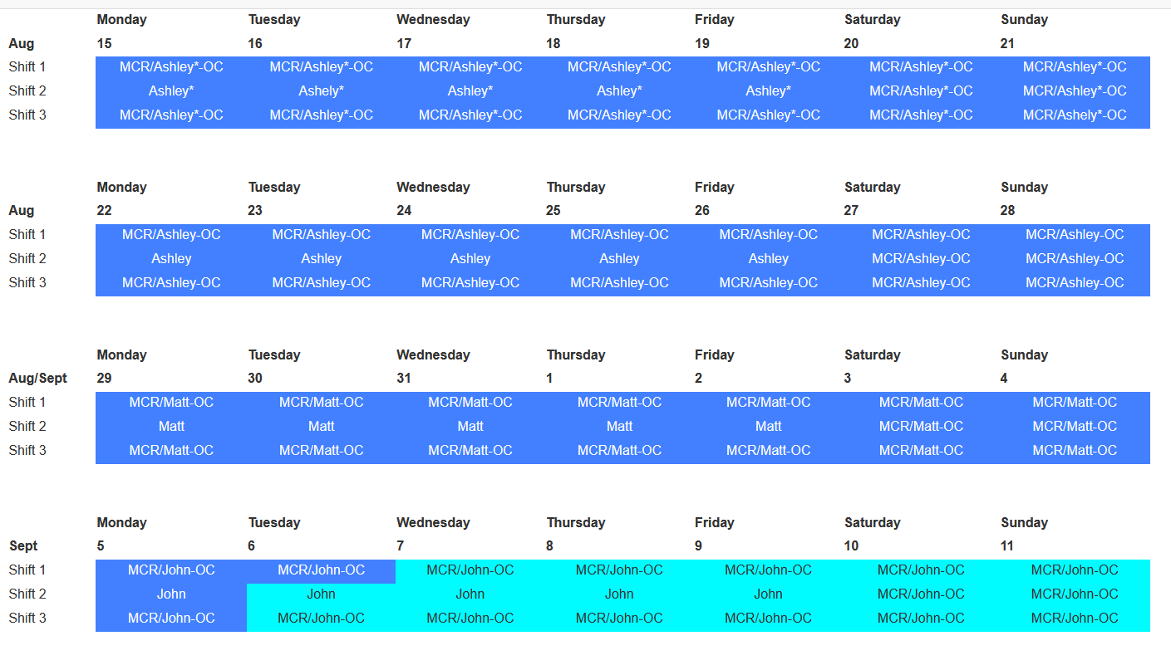

Vacation/DORs:
John Mazzio – 9/1 - 9/2

EFOG-POC Ongoing list:
- EFOG POC-Roadwork schedule and impact–Clay White
- EFOG POC-APSU BPA Fixed Price Scheck: SOW, WPC-Ashley Wayman
- EFOG POC-8-ID/9-ID Decommissioning: Clay White
- EFOG POC-Sector 20 move out and move in: Matt Spilker
- EFOG POC-LBB –Ashley Wayman, Matt Spilker
- EFOG POC-Beamline metal/etc. recycling program-Wendy VanWingeren
- EFPG POC-Building Operations Team-Matt Spilker

Experiments of Note:

8/16/2022 - 9/12/2022

- None

Shutdown Planning Meeting notes:

User beam ends: midnight on August 1 (machine studies August 2)
Tunnels open: August 3 Tunnels close: August 31

HELPFUL LINKS
- Shutdown Planning Web Page
- IS_FAC Site Operations Plans for Machine Maintenance Periods
- APS-U Shutdown Work

Pre-Run Work
- Pre Run Checklist: https://anl.box.com/s/4j5di7lmo7p8oa310vx94p7buo5ol83o
- QEW walkthroughs: Upload in box: https://anl.app.box.com/folder/168154020919
- CCCLs walkthroughs
- CCWPs close out/ Type C: https://anl.box.com/s/k4ct1jifqr43ur4rq7d2i7vo3z1hkv25
- Pre Run Meeting: TBD 9/8/2022 10:30am

Round Table Discussion

Nena
- Covid guidance
  - Updated APS web info: https://www.aps.anl.gov/Users-Information/Updates/Covid-Rule-Regulations
- ESAF rules for submission and approval: No Rules
- Reminder: FC day shift hours: 8:30am to 5pm when not on shift.
- Performance Appraisals will start in Sept. Will get input from two people you have worked with.
- Training: Check your training profile. Several people are expired in courses.
- Resumes of 5 candidates, Interview process. Need to decide on top 2 to do onsite visit
  - Elizabeth Hardt- 8/18/22 at 12pm
  - Jamie Erdman - 8/19/22 at 11am
  - Dmitriy Ronzhin - 8/23/22 at 10am
  - Chris White - 8/23/22 at 1pm
  - Riddhi Vyas - 8/25/22 at 12pm
Liz
- User beam returns at 8am on Tuesday, September 13, 2022
- Machine studies start at 8am on Friday, September 30, 2022 and end at 8am on Monday, October 3, 2022
- 2022-3 run starts at 8am on Monday, October 3, 2022 and user beam ends on Tuesday, December 20, 2022 at midnight
Bruce
- Current ESAF Vector requests for Jennifer:
  - Remove dates from the Experiment Setup tab. -COMPLETED
  - Restrict User_type = “Beamline Staff” to APS employees and Resident Users.
  - Add copies of the POC and Host fields (on the Beamline Admin tab) to the Comment Summary tab. Add the Host Name field to the ESAF EA form.
  - Restrict users on ESAF to valid site access:
- Looking at ESAFs.
Bruno
- 3-ID-C having 2 outlet strips installed on the internal inboard wall.
- 3-ID-C technical staff running cable tray on external inboard wall after having reviewed with Mike Fries and safety protocol.
  - Per Clay; Patti’s committee is waiting for a response from the beamline
- 3-ID-C staff pricing the cost of a new roof labyrinth, seems too expensive.
- Sector 5 ongoing work for Gas Cabinet Transfer Lines Rerouting.
- 5-BM-B acquiring estimate to install a 480V outlet and related switch for The Upgrade.
- 5-BM-A to have very large beam flight path removed by Rigging Crew for The Upgrade.
- 8-ID RSS tags have been mostly removed, except for ~4 wall labyrinths very high up and presently difficult to access due to pallets and equipment in the way.
- 435/LBB Truck Lock ODH monitor has been installed then calibrated & tested on 7-18-22. (This will be included in the ODH rotation of calibrations).
- KEEP IN MIND: Due to frequent LN2 venting, the following station mounted ODH monitors may alarm on a regular basis: 10ID-A, 21ID-D, 4ID-B (alarms cannot be silenced).
- 4 portable O₂ monitors: Portable O2 monitors have been issued to several experimental stations. Please be aware that O2 monitors are at 1BMC, 4IDD, 20IDA, 25IDB
- Besides 432, Bruno will be the 431 area Floor Coordinator until further notice. Which includes the 431 LSIs, LOTO board inspections and 431 eyewashes. Beamline staff were notified of this from 1-BM through 4-ID.
Clay
- Construction of Sector 8 & 9 on schedule for Fall:
  - 8ID and 9ID have been decommissioned by APS management. Deconstruction of both beamlines has begun. FES locked out and air LOTOed on both lines, and disconnection of vacuum components under way. No disconnection of transport yet, pending approval of flange box disassembly procedure
  - 9ID-C (USAXS) and 9ID-B (Bionanoprobe) have begun their moves to 20ID and 2ID, respectively. This work is ongoing. New USAXS instrument arrived and installation/validation has begun inside 20ID-B
  - The fate of 8-BM is still unknown. BL expected to operate in October, but whether it does remains dependent on separation of 8ID and 8BM utilities. Likelihood of 8BM operations continuing appears no better than 50/50.
  - 9-BM will run through the end of September (13th-30th), then go down until the end of the Dark Period. 9BM will then be the first BM line to start rotational and translational moves for the new lattice. This move will be instructive for the remaining 17. Meeting Wednesday.
  - 9BM-C inboard door welding scheduled for Oct 2nd
- Bionanoprobe will try to take beam at 2-ID in mid-September
- Future work: Grinding SR wall at 11-BM-A first design review tomorrow. Contractor visits for site and SOW assessment complete.
- WPC/ JSA Aerotek at Sector 20 the week of 8/29, possibly here into next week. Techs now on site
- 7-IDC new labyrinth installation complete. Bruno will make tag and update CCCL
- 10BM mask to white beam stop swap under way, but vacuum leaks outside the area of the two components are slowing completion
- One-sided labyrinth design for Upgraded 19ID-E appears ready for approval. Final design will require Access Shields as configuration control items
- Close out all work inside the tunnels before 8/31 closure: Close FE CCWPs
- Targeting Thursday, the 8th for Pre-Run meeting
John
- Oxygen monitors are being tested and calibrated.
- Rad survey schedule for 2022-3 starting to take shape.
Matt
- 438
  - 35-ID-C electrical outlet install in progress, welding will begin soon, conduit to be installed soon as well, CCWP posted
  - 34-ID-A SR penetration cutting for APS-U to begin this week, CCWP posted
  - Couple of water leaks found in the LOM last week, Ashley swooped in and saved the day
- 435
  - 20-ID
    - Large amount of progress made in move to 25
      - Working with the Papester and Shelly to get tables and other large furniture moved from 437 to sector 25. Meeting with Rob Lang to discuss this later in the week.
    - Ivan, Jan and Matt Frith from sector 9 have moved in like freshman on welcome week. Most of their equipment is in place, will continue connecting and arranging their setup. Lots to throw out
    - Awaiting response form Andy Stevens on getting Scheck to run a GN2 line from the drop-down point in the hall to the front of 20-ID-B where existing gas lines enter through a labyrinth

  - 19-ID
    - Not having a fun time last week, luckily Mark Martins saved the day
      - Their Ion pump on the empty mono tank in 19-ID-C has been acting strange, running hot to the touch, high current pull, and only getting down to 1.4x10-8.
      - MOM-Vac tried a couple leak checks but weren't able to find anything, opted to swap out the pump on Friday
      - Vacuum is about the same, low –8's however the current pull is normal again and the Ion pump is not hot, Zou is satisfied and believes they will be fine running at this vac level.
  - 18-ID
    - Waiting for White BPM to be delivered, hopefully will be installed by end of shutdown, CCWP for Yoko install
    - Waiting on update for this
    - Rick would like to call dibs on some of the equipment at 19-ID that is being removed for the LBB upgrade
      - Interested in the Mono 2, Mirror, and the Ion Pump 4 support stand in the C hutch just downstream of ISV3
  - 17-ID
    - It is eerily quiet, seems like they are doing alright for now
  - 17-BM
    - Nothing going on as usual
  - Shipments being stored in the 435/436 Truck lock for APS-U and LBB work
    - Not sure how to proceed with riggers bringing in equipment to the LBB, considered a lead work area but is receiving shipments
  - Joined the Building Operations Team, if anyone wants me to bring something up in the meetings let me know.
Ashley
- Will be looking at Training Manual and updating as necessary-let me know if you want to help.
- Scheck BPA WPCs are starting to come in. Local FCs will be included on approval chain for notification.
- 7ID labyrinths Kit CCWP: who is handling making new tag and updating CCCL(Bruno)
- Work with Bruno on 432C Floor Stripping (planning weekend 9/3-9/4)
- Everyone should do Building Orientation for 444 and get access.
Shane
- Verify that Flcoord password has been changed in the 3 areas and inform FCs. APS Domain account. (wendy will send email instructions to Shane)
- 28ID-B Lowering of beamline table. VAC group starting today, removal of current zero length adaptors. RSS work of Survey lowering optics table 17mm starting tomorrow. CCWP posted this afternoon
- Last week’s ERP tie-in work went well for my areas. Many unaffected, others had minimal preparation needed.
- Energetics brought to 7BM for experiment in later September.
- 27-ID majority of work is done (moving the table).
- 3 new computers –Wendy, Shane, Bruno
Steve
- Steve is currently scheduling DEEIs but Nena and Liz are on standby and can help if needed.
- Steve will be back for Sept/Oct shifts.
Wendy
- Tunnels close Wednesday, 8/31. Please have all FE CCWPs through validations complete by 10am on Wednesday, 8/31.
- If beamlines have scrap metal, wires (copper) or small amounts of lead that they want to get rid of please let me know.

