Present: Nena, Matt, Liz, Ashley, Clay, Bruno, John

FC Shift Presence: 7/18/22-8/1/2022

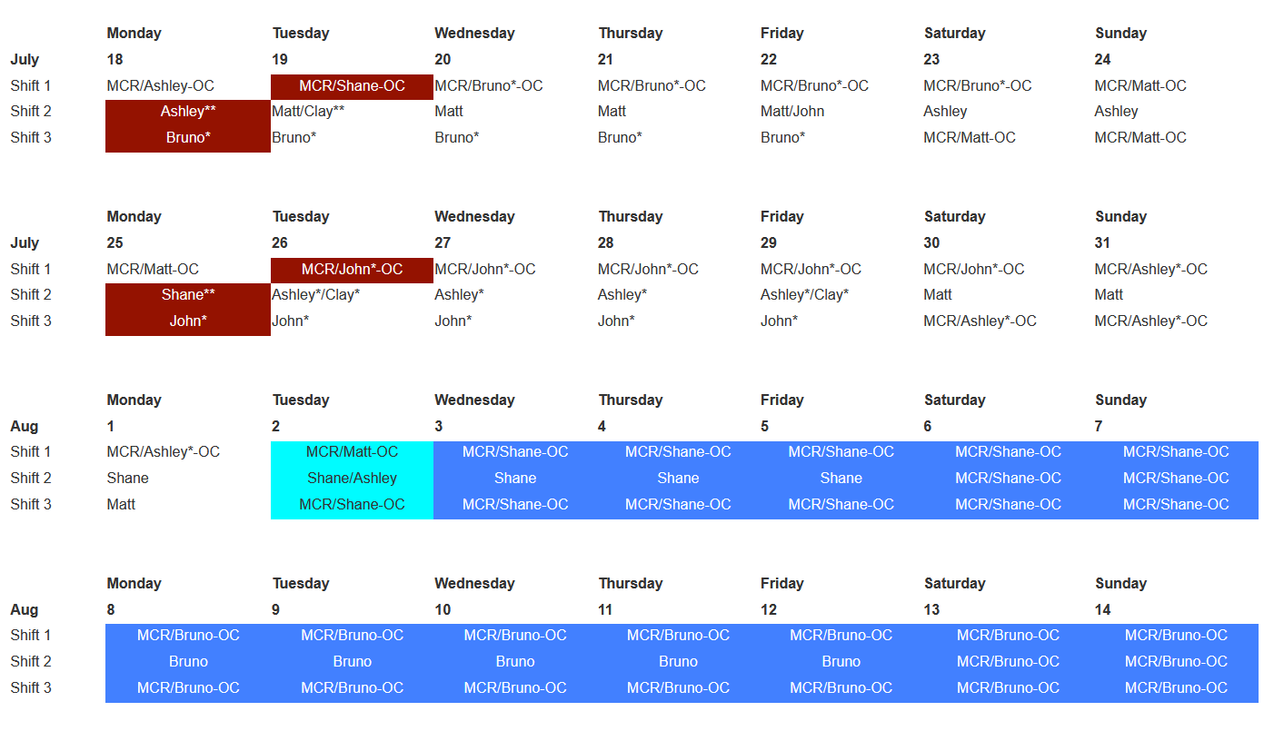

Vacation/DORs:
Shane Flood - 7/18 - 7/22
Ashley Wayman - 7/21 and 7/22
Nena Moonier-7/22 ½ VAC

Events from Last week and things to look out for:
- Water leak 16BM rachet door
- 436 Lab drains
- Sector 25 SV
- 22ID water work
- 25ID transport bracket swap
- 9ID/10ID strobe relay

Experiments of Note:

7/18/2022 - 8/2/2022

- ESAF 257087 at 12-BM-B. Onsite users from UNLV. 07/20/22 - 07/21/22. Radioactive Samples
- ESAF 257981 at 16-BM-B. Onsite users from LANL. 07/20/22 - 07/23/22. Explosive Samples (samples already at APS from a previous experiment)
- ESAF 258983 at 13-BM-D. Onsite users from MSU. 07/2022 - 07/25/22. Regulated Soil (meeting scheduled with users on 7/20 at 9:30am)

- ESAF 257552 at 4-ID-D and 432 B030. Onsite users from University of Liverpool. 07/26/2022 - 08/02/22. Open Flame Permit (meeting scheduled with ANL FD on 7/26/22 at 10am to issue permit for work in 432 B030; Matt will be the permit holder)
- ESAF 259091 at 16-BM-D. Onsite users from LANL. 07/26/22 - 07/28/22. Radioactive Samples
- ESAF 259102 at 33-BM-C. Onsite users from CSE division at ANL. 07/26/22 - 8/2/2022. Radioactive Samples
- ESAF 258835 at 10-ID-B. Onsite users from BIO division at ANL. 07/28/22 - 8/2/22. Radioactive Samples
- ESAF 258802 at 16-BM-D. Onsite users from LANL. 07/28/22 - 07/30/22. Radioactive Samples

Shutdown Planning Meeting notes:

User beam ends: midnight on August 1 (machine studies August 2)
Tunnels open: August 3 Tunnels close: tentatively August 31

Non-routine/routine work of interest:
- ID swap at 34-ID (N. Weir): routine work
- Network switch upgrades (B. Pruitt)
  - Beamline network switch upgrades: 17BM and 29ID (waiting for hardware)
  - LBB B444 network switch upgrade (waiting for hardware)
- From IS/FAC (Dan Preuss)
  - Sitewide steam shutdown August 5-22: temp boilers will be brought into 450 as in the past, should be transparent in the changeover and during the shutdown.
  - LTHW work possibly in the EAA- more to come on this
  - Kearney Road closure- continues through November
The Dec/Jan 2023 shutdown was then talked about, each meeting will go over list of things that absolutely need to be completed before the dark time (so either Aug/Sept or Dec/Jan).
Non-routine/routine work noted for Dec/Jan shutdown:
- ID swap at 21-ID
- Nb3Sn SCU installation
- Network Upgrades
  - Upgrade CAT core network switches
  - Install beamline network single mode fiber: floor racks to LOM closets
HELPFUL LINKS
- Shutdown Planning Web Page
- IS_FAC Site Operations Plans for Machine Maintenance Periods
- APS-U Shutdown Work
Likely to be another complete power shutdown. Clay will provide further information after an upcoming meeting.

Round Table Discussion

Nena
- Covid guidance
  - Updated APS web info: https://www.aps.anl.gov/Users-Information/Updates/Covid-Rule-Regulations
- ESAF rules for submission and approval:
  - Starting 2022-2 run will allow 5 onsite non ANL users per ESAF.
- Reminder: FC day shift hours: 8:30am to 5pm when not on shift.
- Building Evacuation Drill: 9:30 am August 2nd
- New role - Wendy VanWingeren
- Mohan, Mark Edrman, Bob Winarski to attend our 7/25 meeting to discuss FC help with APS U (may have to reschedule).
Liz
- XSD-MIC (2-ID-D,E; 8-BM; 34-ID-C) TYSSR scheduled for July 20th at 11am on Teams
  - Need RSS Interface Document information from Bruno
Bruce
- APS ESRB now has the ability to update the MC_flag in ESAF.
- Current ESAF Vector requests for Jennifer:
  - Remove dates from the Experiment Setup tab.
  - Restrict User_type = “Beamline Staff” to APS employees and Resident Users.
  - Add copies of the POC and Host fields (on the Beamline Admin tab) to the Comment Summary tab. Add the Host Name field to the ESAF EA form.
- Looking at ESAFs.
Bruno
- Sector 5 Gas Cabinet Transfer Lines Rerouting: I have met with Mike Guise (Sec5) and Andy Stevens, after emailing the scope of work, for a final discussion on details.
- KEEP IN MIND: Due to frequent LN2 venting, the following station mounted ODH monitors may alarm on a regular basis: 10ID-A, 21ID-D, 4ID-B (alarms cannot be silenced)
- 435 Truck Lock ODH: The ODH monitor has been installed and needs to be calibrated by Bruno.
- ESH436 PR: This online course and practical demonstration can be used for outside contractors as per Mike Fries. Bruno will schedule sessions with Jeff Collin’s & John Grimmer’s people when needed.
- Ongoing ESH436 PR: Ongoing demonstrations/training for ESH436 PR are in the process of being scheduled for several beamline staff members on the Experimental Floor. If approached by any staff as to the status of their training date, please relay to them that I will be contacting them shortly and please thank them for their patience.
- 4 portable O₂ monitors: Portable O2 monitors have been issued to several experimental stations. Please be aware that O2 monitors are at 1BMC, 4IDD, 20IDA, 25IDB
- Besides 432, Bruno will be the 431 area Floor Coordinator until further notice. Which includes the 431 LSIs, LOTO board inspections and 431 eyewashes. Beamline staff were notified of this from 1-BM through 4-ID.
- Roofing company is at various locations on the floor repairing the leaks in the roof. Roofing company will come out on days that it is raining.
- WPC/JSA for calibration of digital scales sector 5 Aug 15
Clay
- Construction of Sector 8 & 9 on schedule for Fall:
  - 8ID and 9ID will come down at the start of Aug/Sep shutdown and will not come back up in their current forms. Decommissioning both lines to begin then.
  - 9ID-C (USAXS) will wrap operations at the end of June, and begin the move to 20ID shortly thereafter. USAXS out of 9ID at end of July “no matter what”
  - 9ID-B (Bionanoprobe) will continue to operate normally through July 2022, then begin the move to 2ID
  - Operations will be affected in 8-BM, but there is no final decision on whether it will remain operational after the Aug/Sep 2022 shutdown
  - 9-BM will run through the end of September (13th-30th), then go down until the end of the Dark Period
  - 9BM-C inboard door welding on schedule for Aug/Sep shutdown
  - New T&M contract in place, but no concrete information about disentangling BM and ID utilities at sector 8.
- Bionanoprobe will try to take beam at 2-ID in mid-September
- Future work: Grinding SR wall at 11-BM-A to accommodate moving their mono 3 inches inboard; shielding studies on going this time – No change
- WPC/ JSA Aerotek at Sector 20 Sometime in August
- Water at 16BM: fitting still leaking, water in exp floor, tunnel access found fitting not tighten. Believed to be fully repaired
- CCWP at 9ID and 10 ID relays completed and can be closed
- 7-IDC new labyrinth during this shutdown.
John
- Sector 14 BM will not be running at this time. AR is posted. APS disabled of all stations and global offline.
- 4 routine rad surveys 7/19 tomorrow morning 24ID, 30ID, 13BM, 1BMC
- Checked 16BM –no water coming through door.
Matt
- Sector 20 has hired Scheck to remove the Al plate cemented into the floor of the 20-ID-B hutch. Work will begin first week of August shutdown, want to be done by August 15th
- LBB Status- 20-IDE buildout timeframe. Caratelli working on the 20IDE hutch
- Matt will take over 438 responsibilities during Steve’s absence
  - Will complete the 438 eyewash/LSI inspections. John will do 438 LOTO board
  - Will follow up on beamline requests for 438.
Ashley
- 436 drain issues: 436 lab drains have been backing up. Source of issue is a crushed pipe caused by LBB construction. Lab water to 436 is shut off and chemical work suspended. A temporary pump system is in place to transfer any water in the lab line from mezzanine equipment into the sanitary drain. Latest update is excavation work will start Tuesday for the repair.
- 25ID: Shielding Verification is officially done (per memo APS_2206855). One last check of multi-layer mono beam will be completed once final mirrors installed (TBD). G. Banks is completed BLEPs updates. Type C for transport line 7/19.
- Dectris visiting Sector 22 week of Aug 10
- 435 truck lock O2 monitor installed. Just needs calibration.
- 22ID water issues. Flow to stop in C station. Readjusted set points
Shane
- Will enter a VECTOR to move the 437 lock box from Steve’s office to 437 C002.
Steve
- Steve is currently scheduling DEEIs but Nena and Liz are on standby and can help if needed.
Wendy
- 431: JSA/WPC/WEC for MTS visit to 1ID-E cage for routine maintenance and troubleshooting the MTS load frame and hydraulic pump (now expected Wed. 6/29)
- 438: JSA/WPC/WEC for Julich to install and commission new chopper for DCS/35ID (originally scheduled for this week, now postponed - no new dates yet).

