Present: Nena, Liz, Bruno, Matt, Wendy, Clay, Bruce, Ashley, Shane

FC Shift Presence: 6/27/22-7/31/22

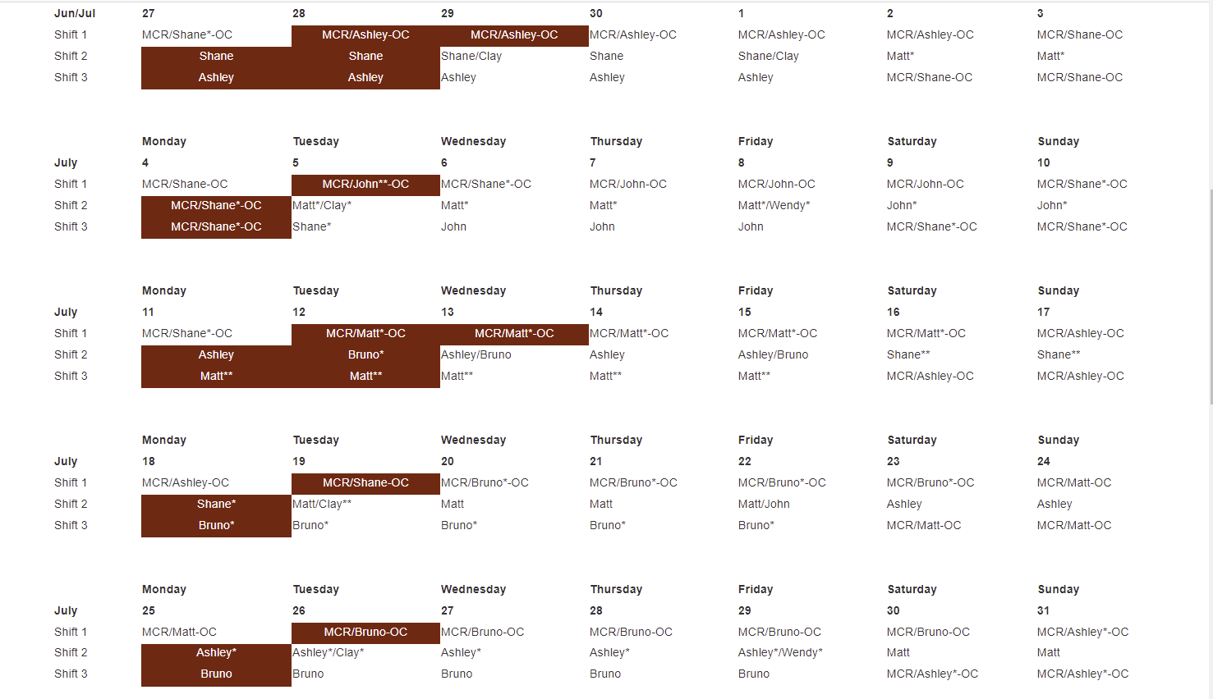

Vacation/DORs:
Nena Moonier-7/1 ½ VAC
Bruno Fieramosca-6/28,6/29,6/30
John Mazzio-6/27, 6/28, 6/29, 6/30
Liz Schmidt- 6/30
Shane Flood – 6/28

Events from Last week and things to look out for::

- 2-0101 paging outage: no issues at this time
- The 14-ID-C Shutter is once again having issues.
  - Vacuum group sourced a new cylinder previously but may need to source an upgraded cylinder
  - Cleaned and lubricated today.
  - Keep an eye on the situation for now.
- Work on FM2 and PS2 at 1ID last Monday. PS2 shutter solenoids replaced by Vacuum Group and one cooling channel bypassed on FM2 to resolve a leaking brazed joint. Multiple independent calculations verify adequate cooling headroom even with one channel down. FM2 to remain in this config for the remainder of the run.
- Work completed this morning on door switches at 33-ID-E, cleaning only, no adjustment or replacement of parts, no Type C necessary.

Experiments of Note:

6/27/2022 - 7/4/2022
- ESAF 257776 at 20-ID-C. Onsite users from Washington State. 06/29/22 - 07/02/22. Radioactive Samples
- ESAF 258066 at HP-CAT lab/ruby system. Onsite users from Washington State. 06/29/22 - 07/01/22. Radioactive Samples
- ESAF 257747 at 12-ID-D. Onsite users from ANL MSD division. 07/13/22 - 7/18/22. High Risk ESAF. Walk down of experiment on 7/12. EA requires signature by APS ESRB. Please call Liz when the users are ready to post.

Shutdown Planning Meeting notes:

User beam ends: midnight on August 1 (machine studies August 2)
Tunnels open: August 3 Tunnels close: tentatively August 31

Non-routine/routine work of interest:
- ID swap at 34-ID (N. Weir): routine work
- Network switch upgrades (B. Pruitt)
  - Beamline network switch upgrades: 17BM and 29ID (waiting for hardware)
  - LBB B444 network switch upgrade (waiting for hardware)
- From IS/FAC (Dan Preuss)
  - Sitewide steam shutdown August 5-22: temp boilers will be brought into 450 as in the past, should be transparent in the changeover and during the shutdown.
  - LTHW work possibly in the EAA- more to come on this
  - Kearney Road closure- continues through November
The Dec/Jan 2023 shutdown was then talked about, each meeting will go over list of things that absolutely need to be completed before the dark time (so either Aug/Sept or Dec/Jan).
Non-routine/routine work noted for Dec/Jan shutdown:
- ID swap at 21-ID
- Nb3Sn SCU installation
- Network Upgrades
  - Upgrade CAT core network switches
  - Install beamline network single mode fiber: floor racks to LOM closets
HELPFUL LINKS
- Shutdown Planning Web Page
- IS_FAC Site Operations Plans for Machine Maintenance Periods
- APS-U Shutdown Work
Likely to be another complete power shutdown. Clay will provide further information after an upcoming meeting.

Round Table Discussion

Nena
- Covid guidance
  - Updated APS web info: https://www.aps.anl.gov/Users-Information/Updates/Covid-Rule-Regulations
- ESAF rules for submission and approval:
  - Starting 2022-2 run will allow 5 onsite non ANL users per ESAF.
- Mike Wachel APS waste specialist. Mike Wachel, Office: 437 D008, Email: mwachel@anl.gov, Desk Phone: 2-6682
- Dec-Jan Maintenace shutdown may be shortened by 1 week. Tunnels would close on Jan 12 and machine studies Jan 20. 2023-1 potentially start Jan 26. Dark Period still scheduled to start April 17, 2023
Liz
- XSD-MIC (2-ID-D,E; 8-BM; 34-ID-C) TYSSR scheduled for July 20th at 11am on Teams.
- NX School ESAFs – Waiting for further information from local beamline staff
Bruce
- Submitted request to allow APS ESRB the ability to update the MC_flag in ESAF.
- ESAF EA Checklist updated to include question about temperature limits of heating devices.
- ESAF Requirements table updated to include new guidance for heating devices.
- Looking at ESAFs.
Bruno
- Sector 5 Gas Cabinet Transfer Lines Rerouting: I have met with Mike Guise (Sec5) and Andy Stevens, after emailing the scope of work, for a final discussion on details.
- KEEP IN MIND: Due to frequent LN2 venting, the following station mounted ODH monitors may alarm on a regular basis: 10ID-A, 21ID-D, 4ID-B (alarms cannot be silenced)
- 435 Truck Lock ODH: The ODH monitor has been received and is in Bruno’s office (clearly labeled). Andy Stevens has been notified and is working with the Maintenance Group to accomplish installation of the new O2 alarm system.
- ESH436 PR: This online course and practical demonstration can be used for outside contractors as per Mike Fries. Bruno will schedule sessions with Jeff Collin’s & John Grimmer’s people when needed.
- Ongoing ESH436 PR: Ongoing demonstrations/training for ESH436 PR are in the process of being scheduled for several beamline staff members on the Experimental Floor. If approached by any staff as to the status of their training date, please relay to them that I will be contacting them shortly and please thank them for their patience.
- 4 portable O₂ monitors: Portable O2 monitors have been issued to several experimental stations. Please be aware that O2 monitors are at 1BMB, 4IDD, 20IDA, 25IDB
- Besides 432, Bruno will be the 431 area Floor Coordinator until further notice. Which includes the 431 LSIs, LOTO board inspections and 431 eyewashes. Beamline staff were notified of this from 1-BM through 4-ID.
- Roofing company is at various locations on the floor repairing the leaks in the roof. Roofing company will come out on days that it is raining.
- Square One is onsite at 7-ID working on detector robot; paperwork is on Bruno’s door
Clay
- Construction of Sector 8 & 9 on schedule for Fall:
  - 8ID and 9ID will come down at the start of Aug/Sep shutdown and will not come back up in their current forms. Decommissioning both lines to begin then.
  - 9ID-C (USAXS) will wrap operations at the end of June, and begin the move to 20ID shortly thereafter. USAXS out of 9ID at end of July “no matter what”
  - 9ID-B (Bionanoprobe) will continue to operate normally through July 2022, then begin the move to 2ID
  - Operations will be affected in 8-BM, but there is no final decision on whether it will remain operational after the Aug/Sep 2022 shutdown
  - 9-BM will run through the end of September (13th-30th), then go down until the end of the Dark Period
  - 9BM-C inboard door welding on schedule for Aug/Sep shutdown
  - New T&M contract in place, but no concrete information about disentangling BM and ID utilities at sector 8.
- Bionanoprobe will try to take beam at 2-ID in mid-September
- Future work: Grinding SR wall at 11-BM-A to accommodate moving their mono 3 inches inboard; shielding studies on going this time – No change
- 12ID-D inboard door supplemental shielding restored and doors closed. Will need a Type C when D station resumes operation in July. For now, 12ID is only operating in B and C stations. Type C required.
John
- 438 LOTO board inspection has been completed.
- Sector 14 BM will not be running at this time. AR is posted. APS disabled of all stations and global offline.
Matt
- Sector 20 is getting quotes for the removal of the Al plate cemented into the floor of the 20-ID-B hutch.
  - Work will begin first week of August shutdown, Scheck doing the work; want to be done by August 15th
- LBB Status- 20-IDE buildout timeframe.
  - Final occupancy for LBB should be within the week.
- Matt will take over 438 responsibilities during Steve’s absence
  - Will complete the 438 eyewash/LSI inspections. John will do 438 LOTO board
  - Will follow up on beamline requests for 438.
- Unusually hot in the 435 exp hall, maintenance is investigating
  - 19-BM-D extremely hot
Ashley
- 436 FedEx pickup area open (C Pentagon). Please let me know if there are issues reported. FedEx may have acknowledged that there is a pick-up area in 436.
- It’s June! Time for the a LOTO inspection. Form is ANL-1063 in XINK.
- EFOG cage cleanup of 2-ID ladders and Alp’s gas cylinders-Bruno to follow up – Move cylinder to outside of cage?
- May need to order another lock for the cage
Shane
- Will enter a VECTOR to move the 437 lock box from Steve’s office to 437 C002.
- 25ID:
  - FDR approval granted. Egress issues created by the A-B shielded transport and stairway will need to be addressed.
  - SI performed PSS commissioning today, CCWP posted
  - 25ID Shielding verification status:
    - Transport from A to B essentially complete
    - B completed up to inboard and outboard monos, will resume after transport is fitted out to both monos and the stops/shutters at the downstream end of B. This buildout is needed for the SV of the downstream wall of B. Scheduled for this Friday with beam tuning preceding this on Thursday.
    - C SV planned for early next week. This will include the shielded transport in C that runs to D and E.
- 26ID: Commissioning of new mirrors and mono, Final type C surveys completed - final survey of the guillotine and exit port in C was completed at a 17 mm gap for both the US and DS IDs.
AR describing this new limit posted. Additionally, the BL commissioning limits for both IDs has been updated to 17 mm.
Steve
- Steve is currently scheduling DEEIs but Nena and Liz are on standby and will help if needed.
Wendy
- 431: JSA/WPC/WEC for MTS visit to 1ID-E cage for routine maintenance and troubleshooting the MTS load frame and hydraulic pump (now expected Wed. 6/29)
- 438: JSA/WPC/WEC for Julich to install and commission new chopper for DCS/35ID (originally scheduled for this week, now postponed - no new dates yet).

