Present: Nena, Liz, Wendy, Bruno, Shane, Ashley, Bruce, John

FC Shift Presence: 6/13/22-7/03/22

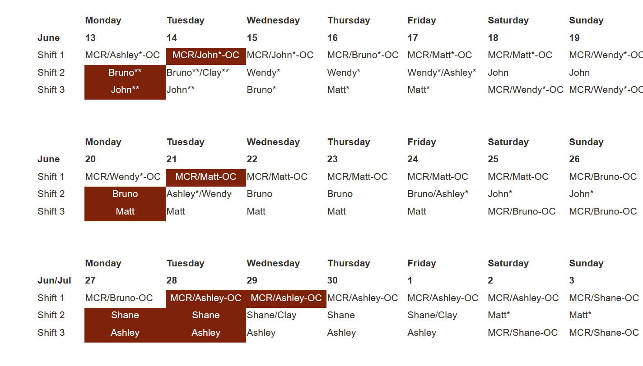

Vacation/DORs:
Matt Spilker- 6/13
Clay White-6/13
Nena Moonier-6/17
Bruno Fieramosca-6/17
John Mazzio-6/17

Events from Last week:

- 2-0101 paging outage: Started Friday 6/10. Derek Steinkamp has been investigating, seems that ATT is blocking the paging to text portion. Per update this morning, ATT dropped the 3g phone plan we were on. Updates ongoing. Impact for Tuesday?
- 24-29 Process water pump issues – 1 pump put into manual mode and able to bypass the problem by taking that action (this was last week). A switch was changed out today. All flows look good, they just need to be reset.

Experiments of Note:

6/13/2022 - 6/20/2022

- ESAF 254069 at 33-ID-D. Onsite users from ANL CSE division. 06/14/22 - 06/17/22. Radioactive Samples
- ESAF 256481 at 16-ID-D. Onsite users from UIC/UCSD. 06/14/22 - 06/18/22. Radioactive Samples
- ESAF 257148 at 16-BM-D. Onsite users from Notre Dame. 06/17/22 - 06/20/22. Radioactive Samples
- ESAF 256873 at 16-ID-B. Onsite users from LANL. 06/18/22 - 6/20/22. Explosive Samples

Round Table Discussion

Nena
- Covid guidance
  - Updated APS web info: https://www.aps.anl.gov/Users-Information/Updates/Covid-Rule-Regulations
- ESAF rules for submission and approval:
  - Starting 2022-2 run will allow 5 onsite non ANL users per ESAF.
- Mike Wachel APS waste specialist. Mike Wachel, Office: 437 D008, Email: mwachel@anl.gov, Desk Phone: 2-6682
- Dec-Jan Maintenace shutdown may be shortened by 1 week. Tunnels would close on Jan 12 and machine studies Jan 20. 2023-1 potentially start Jan 26. Dark Period still scheduled to start April 17, 2023
- Tuesday June 14, 9am. APS Upgrade Q&A session via Teams
- Tuesday June 14, 10am. AES All-Hands Meeting via Teams
Liz
- IMCA-CAT TYSSR scheduled for June 15 at 1pm on Zoom (meeting link sent by Lisa Keefe).
- Matt is the new backup for regulated soil.
- ESRB meetings are starting up again. The first meeting is Friday, June 24th at 10am on Teams. The ESRB will meet every other Friday at 10am. Will send updated ESAF comments to ESRB via email.
Bruce
- Submitted request to allow APS ESRB the ability to update the MC_flag in ESAF.
- Looking at ESAFs.
- Should find out from Arvind if he has any screen shots of the new proposal system. This could help to guide us for the ESAF rebuild during the dark period.
Bruno
- Sector 5 Gas Cabinet Transfer Lines Rerouting: I have met with Mike Guise (Sec5) and Andy Stevens, after emailing the scope of work, for a final discussion on details.
- KEEP IN MIND: Due to frequent LN2 venting, the following station mounted ODH monitors may alarm on a regular basis: 10ID-A, 21ID-D, 4ID-B (alarms cannot be silenced)
- 435 Truck Lock ODH: The ODH monitor has been received and is in Bruno’s office (clearly labeled). Andy Stevens has been notified and is working with the Maintenance Group to accomplish installation of the new O2 alarm system.
- ESH436 PR: This online course and practical demonstration can be used for outside contractors as per Mike Fries. Bruno will schedule sessions with Jeff Collin’s & John Grimmer’s people when needed.
- Ongoing ESH436 PR: Ongoing demonstrations/training for ESH436 PR are in the process of being scheduled for several beamline staff members on the Experimental Floor. If approached by any staff as to the status of their training date, please relay to them that I will be contacting them shortly and please thank them for their patience.
- 4 portable O₂ monitors: Portable O2 monitors have been issued to several experimental stations. Please be aware that O2 monitors are at 1BMB, 4IDD, 20IDA, 25IDB
- Wendy and Bruno have worked out shared responsibility for the 431 area. Bruno completing 431 LSI and LOTO board inspections, Wendy- all 431 eyewashes.
- Roofing company is at various locations on the floor repairing the leaks in the roof. Roofing company will come out on days that it is raining.
Clay
- Construction of Sector 8 & 9 on schedule for Fall:
  - 8ID and 9ID will come down at the start of Aug/Sep shutdown and will not come back up in their current forms. Decommissioning both lines to begin then.
  - 9ID-C (USAXS) will wrap operations at the end of June, and begin the move to 20ID shortly thereafter. USAXS out of 9ID at end of July “no matter what”
  - 9ID-B (Bionanoprobe) will continue to operate normally through July 2022, then begin the move to 2ID
  - Operations will be affected in 8-BM, but there is no final decision on whether it will remain operational after the Aug/Sep 2022 shutdown
  - 9-BM will run through the end of September (13th-30th), then go down until the end of the Dark Period
  - 9BM-C inboard door welding on schedule for Aug/Sep shutdown
  - Still no new T&M contract in place, so concrete planning is difficult, especially for disentangling BM and ID utilities at sector 8
- Bionanoprobe will try to take beam at 2-ID in mid-September
- Future work: Grinding SR wall at 11-BM-A to accommodate moving their mono 3 inches inboard; shielding studies on going this time – No change
- 9ID-C inboard door reported as “sluggish” by BL staff last week. Investigated by MOM group this morning and operating normally
- 12ID-D inboard door supplemental shielding removed for SA Group access. Will need a Type C when D station resumes operation in July. For now, 12ID is only operating in B and C stations
John
- Will cover 438 LOTO board
- Sector 14 BM will not be running at this time. AR is posted. APS disabled of all stations and global offline.
Matt
- POC for He recovery work
  - Work nearing completion inside hutches, finishing up this afternoon
- Sector 20 is getting quotes for the removal of the Al plate cemented into the floor of the 20-ID-B hutch.
Ashley
- 436 FedEx pickup area open (C Pentagon). Please let me know if there are issues reported. FedEx may have acknowledged that there is a pick-up area in 436.
- It’s June! Time for the a LOTO inspection. Form is ANL-1063 in XINK.
- Will open up mini-hutch at 23 next Monday for Greg Banks and will work with HP for the Type C survey.
Shane
- 437 A005 is Shane’s new office location. There is a Floor Coordinator sign on the door.
- Would be a good idea to move the 437 lock box from Steve’s office to 437 C002.
- Energetic material transfers this week and next
  - First experiment is the week of June 14th
- 25-ID
  - Started construction of laser enclosure. Build out is complete but utilities are ongoing.
  - 25ID: Shielding verification on 25ID-A to B transport 6/14, 10:30am start
- 26ID: Commissioning of new mirrors and mono, AR posted with Type C plan (preliminary and final) along with approval memo. Preliminary survey Wednesday, June 8. As of this morning (6/13), they are ready to increase the power on the new mirrors in A. Step 3 of the plan: APS enable will be removed from 26ID-B and C stations, ID commissioning limits changed from 26.2mm to 16mm on both devices. Beamline will slowly lower the gap and increase the power to commission the mirrors. When ready the B and C stations will be enabled with HP present and final type C surveys completed.
Steve
- Steve is currently scheduling DEEIs but Nena and Liz are on standby and will help if needed.
- Wendy will complete the 438 eyewash/LSI inspections.
- Wendy will follow up on beamline requests for 438.
Wendy
- 431: Working on JSA/WPC/WEC for MTS visit to 1ID-E cage for routine maintenance and troubleshooting the MTS load frame and hydraulic pump (June 27 week).
- 438: Working on JSA/WPC/WEC for Julich to install and commission new chopper for DCS/35ID (June 27 week).

