Present:

EFOG Presence onsite: 6/7/21-6/13/21
Mon-Fri FC1: Clay FC2: Matt
Evenings-Steve
Weekend: Ashley
Vacation/DORs: Bruno DOR 6/10-6/11

Things to look out for this week:
- Portable Oxygen monitors: 5ID-A and 20ID-A Please check for normal O2 levels (20.9%) and battery level ~ 3 times per week for on-shift personnel and please report to Bruno if there is a problem.
- Eyewashes/LSI. Eyewashes are due weekly and LSI are due at the end of the month.
- Evening Shift reminder to send FC to MCR turnover email
- LOTO station inspections: Submit every 6 months (June/December). Complete form ANL-1063 in Xink.

Events from last week
- Start up with only minor issues
- All Type C have been completed from start up except for 3ID-C MH (scheduled for 6/29, APS enable has been removed from 3ID-C/D until then).
- 28ID-A: gate valve was closed during type C surveys completed on June 2. Gate valve was damaged (beam burned hole through). AES-MOM vac has replaced the GV, vacuum restored in 28ID-A.

Ongoing work on experimental floor – RSS
- 14ID-C SI looking into shutter warnings – warnings have not recurred in operation since 6/2 and were not repeatable during this morning’s troubleshooting. No repairs made, continue to monitor. Could not get problem to reoccur on Morning of 6/8. Will keep monitoring the situation.
- 9BM PSS Trip with beam dump on 6/2. Maladjusted switches on the station B/C manual beam stop allowed for PSS to “see” an Open state on one chain and a Closed state on the other. Switches re-positioned by AES-SI. Beamline returned to the users same day. Occurred after rad survey. A few things were going on with the PSS panel. Tianpin closed the manual beam stop in B, which should have allowed her to open into C. Disagreement between Chain A and Chain B switches. Adjusted switch depth. Clay submitted downtime report.

Ongoing work on experimental floor/LOMS – Other
- Closer integration of approvals and workflow between EFOG and FAC is under way. Ron Tollner working with on-site ServiceNow reps to bring EFOG into the workflow for 400 area Vector requests. He has already notified Site Operations personnel for the APS to contact us for work in 400, and will start referring XSD and CAT staff to FCs immediately for requests that come in via email or telephone contact.
- Problematic response to service requests from 11BM/ID staff to IT resulted in days of lost productivity following the APS big power shutdown. Assistance from GL to GL? Beamline Downtime report? (Issue with problematic switch)

Completed Repairs and Work
- 7BM-B strobe relay replacement
- 9BM- PSS trip resulting in beam dump: Beamline Downtime Report 780 completed and closed. Details above.
- 28-ID Gate Valve repair and incident

Upcoming Work on experimental floor/LOMs
- Sector 4, 6 & others: -Helium Recovery System-See notes from 3/29
- Sector 5 –Gas cabinet installation-See notes from 3/8 (for dark period)

28-ID IDEA Status
- Equipment installation on-going.
- 28ID-A cryo-deck installation by Scheck will be happening soon. No welding on 28ID-A roof will be done. Was supposed to happen pre-covid but did not happen at that time.

25-ID ASL Status
- Electrical work will start at the end of this month
- 25ID-A shielding verification tentatively scheduled for October 2021 (need electric, water/air and PSS installed first).

LBB Updates
- Activities This Week: Safety cables, decking, walls work and CMU wall installations continue. Soil amending, exterior wall layouts, and beamline corridor concrete pours starting.
- Equipment lifts inside the mezzanine continue. Concrete pouring in mezzanine after adjustment to pad size happening 6/7. Pipe lift next Monday. Heat pumps currently stuck in Italy (6-7 weeks until arrival)
- Items to Keep an Eye on: none
- Looking Ahead: NA
- Scheduling: Typically contractors work from 7:00 a.m. - 3:30 p.m. LBB updates can be found at https://www.aps.anl.gov/Machine-Status/Construction-Schedule/long-beamline-building-construction-schedule

437 lab build out
- Funding issue has been resolved! Contractors set to start in August with completion scheduled for March 2022
- Power Construction awarded the contract
- Clay will work with ANL and contractor and be the POC for our group
- Still no meetings called. A roughly 1000 page set of specs and drawings is still out for review before the project goes to Issued for Construction, though the contract has been awarded to Power Construction. Final comments from all reviewers are due this week.

OPS/XSD GL/PSC Managers/Leader Meeting:
- One personal injury incident- remember to check on people especially those who work alone
- US EPA will be looking at central waste accumulation area and SAA this week.
- Operations: ASD Randy: 97% availability 9-BM PSS trip
- Malcolm Sector 24 steering corrections did not occur. MCR corrected issue because of upgrade and now works
- 437 build out start Aug 27 with completion by March 2022
- Sector 25- laser room build out will start planning soon
- LBB- side panels up over next few weeks. might be delays on roofing. Next vibration activity during Aug shutdown period. LND pad will be poured sometime this month.

Experiments of Note

- Limited Operations + with approved ANL onsite users from divisions outside of PSC and some onsite external users with PSC ALD and DOE ASO approval.
- All risk level work allowed except for Radioactive, Explosive, and BSL2 samples unless the experiment is deemed mission critical or funding dependent, etc. Most experiments are mail-in or remote.
- No plans for change in operation status until after 2021-2 run.

ESAFs with onsite users from ANL divisions outside of PSC have been approved by DOE ASO. ESAFs with external (outside of ANL) onsite users have been approved by both PSC ALD and DOE ASO.

Experiments Running 06/07/2021 - 06/14/2021

Special Experiments:

- ESAF 241624 at 10-ID-B. Ken Kemner from BIO onsite at APS. Start 6/10/2021. End 6/14/2021. Radioactive Samples

Long Duration Lab or No X-Ray ESAFs:

- ESAF 239935 at Sector 7. Chris Otolski and Gilles Doumy from CSE onsite at APS. Start 5/4/2021. End 8/3/2021.
- ESAFs 241561 and 240825 at HP-CAT lab. Ravhi Kumar and Nilesh Salke from UIC onsite at APS. Start 5/28/2021. End 6/24/2021.
- ESAF 241851 at Sector 33. Hui Cao and Xi Yan from MSD onsite at APS. Start 6/7/2021. End 9/30/2021.

Long Term Work Status - APS Upgrade and other APS projects: See EFOG Turnover notes from previous week for more information.

Round Table Discussion

Nena
- See EFOG Turnover notes (below) for further details on Ops, LBB, Shutdown work, general info, etc.
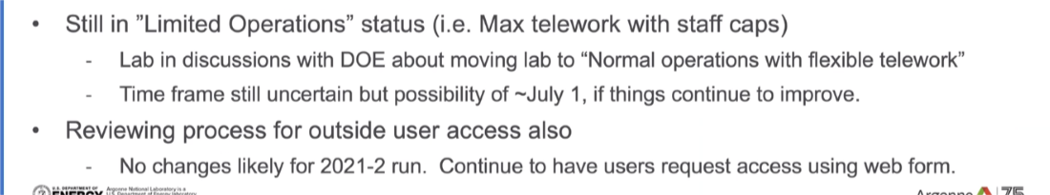
- Mask mandate for fully vaccinated individuals (ANL employees, Argonne Associates, Contractors like Scheck, and CAT beamline personnel) has been lifted. A copy of a person’s vaccination card must be uploaded to Box Plus.
  - Users from outside of ANL must still wear masks regardless of vaccination status: to change soon
  - Cannot ask others their vaccination status.
  - Occupancy numbers in hutches, etc have not changes: To change soon. Numbers have changed in Machine shops. 7-IDC has changed to 4

- 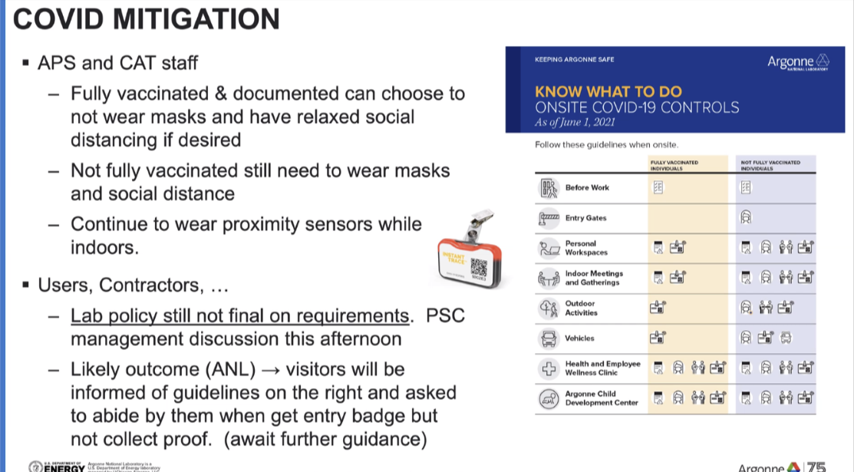
- Increasing EFOG presence on site: if you are not on shift for the week please be on site at least 3 days a week.
- Hybrid work model is being discussed. GLs will make group recommendations by 5/28. Individual discussions will occur around June 15
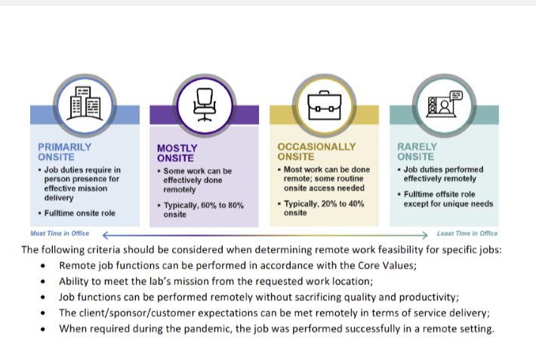
- A folder has been created in EFOG Shared in Box entitled Floor Coordinator Responsibilities and Information.
  - FC ON Shift Responsibilities
  - FC Shift Exchange Template for MCR
  - Floor Coordinator Responsibilities for Three-Year Sector Safety Reviews
  - Troubling Shooting FC1/FC2 Paging System
- Construction on West Gate to begin April 15- Aug 15
  - Will be closed to all traffic from 9am to 3pm during this time
- Met with FAC last week to have our names put on WEC and WPCs; especially for those on the experiment floor. FCs have been added to APS Site Operation Vector tickets so we will get advanced notice
- Nena will work with Tim Smith to put in a key request for 436 E095
  - Shane to work on setting up a computer for Tim by the end of this week.
  - Tim is an Argonne Associate – will be helping out with DEEIs, etc.
- Purchasing items discussed: replace the shared computers, update the tool boxes in each office, monitors for those who want double, printers, Bruno sensors for gas monitors and test gas, portable ozone monitors,1 surface pro to test feasibility of EA checklist, shift log, EPICS etc on portable device. DEEI tools
Liz
- 2 commissioning ESAFs 8-BM-B (241785) and 9-ID-B (241910) still need to be posted
- Working on ESAFs
Bruce
- ESAFs
Wendy
- Straightened up 437 C002
Clay
- Nothing Further
Matt
- Nothing Further
Steve
- DEEI scheduling – will work with Tim Smith once he is fully trained
John
- ESAF table rectified (Katy and John worked on this earlier today)
Bruno
- Steve can you get a hold of someone at 32. They do not seem to have the ability to do steering.
- Square 1 6-14 – 6/18 install detector robot in 7-ID-C
- Ongoing conversation with Zahir, Paul, Mike, etc. Regarding sprinkler install inside 6-ID-C
Ashley
- LOTO custodians – EFOG to do inspections at the same time – complete June and December. ANL-1063 (XINK form) (see link in notes)
Katy
- 3-ID MH Type C completed; C and D disable until ready to run at the end of June

