Present: Nena, Liz, Steve, Shane, Matt, Wendy, Ashley, John, Bruno, Bruce, Clay

FC Shift Presence: 6/6/22-6/20/22

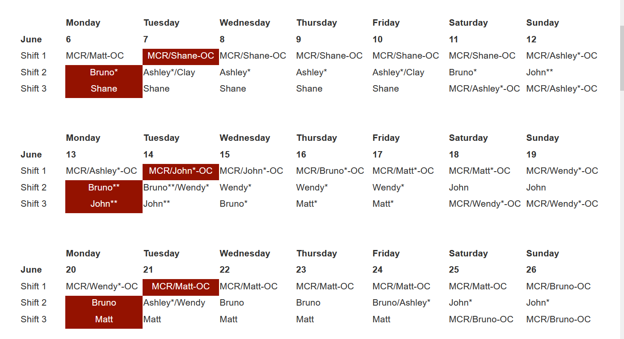

Vacation/DORs:
John Mazzio- 6/6, 6/7, 6/8,6/9
Bruno Fieramosca- 6/7 and 6/10
Nena Moonier- 6/8 and 6/9
Matt Spilker-6/8 and 6/9 and 6/10

Events from Last week:
- User Run 2022-2: Any major issues?
- 27ID, 28ID, 29ID water faults and trips-Resulted in MOM group doing a pump switch over on 6/4
  - Possibly related with power supply issue
  - Switched to backup pump/manual mode on Saturday and haven’t had any problems since that time
- Sector 19-PSS faults related to Chain B I/O module communication fault. June 2, 2022
  - 3 PSS trips overnight that were unrelated but EFOG was not notified overnight
  - Matt put them offline in the morning and contacted SI
  - Wendy posted the CCWP
  - The I/O was power cycled and that was the only action for now

Experiments of Note:

6/6/2022 - 6/13-2022

- ESAF 256567 at 9-ID-C. Onsite users from Notre Dame. 06/09/22 - 06/09/22. Radioactive Samples
- ESAF 256908 at 16-ID-B. Onsite users from LLNL. 06/09/22 - 06/13-22. Radioactive Samples

Round Table Discussion

Nena
- Covid guidance
  - Updated APS web info: https://www.aps.anl.gov/Users-Information/Updates/Covid-Rule-Regulations
- ESAF rules for submission and approval:
  - Starting 2022-2 run will allow 5 onsite non ANL users per ESAF.
- Starting 4/25/22 Mike Wachel will take over for Caroline Fisher-Haase as the APS waste specialist. Mike Wachel, Office: 437 D008, Email: mwachel@anl.gov, Desk Phone: 2-6682
- IT Group contacts for beamline support:
Linux -- Fred Carter, Tom Naughton, Troy Lutes
Windows -- Zac Bastile, Dan DeVito, Steve Potempa
Mac -- Fanping Zhu, Jon Smejkal
Liz
- IMCA-CAT TYSSR scheduled for June 15 at 1pm on Zoom (meeting link sent by Lisa Keefe).
Bruce
- Request to modify ESAF submitted late email is completed and moved to production.
- Request to successfully transfer MC_flag from GUP to ESAF is completed and moved to production.
- Meeting today with Arvind, Jennifer, and Nena to discuss next requests.
- Looking at ESAFs.
Bruno
- Sector 5 Gas Cabinet Transfer Lines Rerouting: I have met with Mike Guise (Sec5) and Andy Stevens, after emailing the scope of work, for a final discussion on details.
- KEEP IN MIND: Due to frequent LN2 venting, the following station mounted ODH monitors may alarm on a regular basis: 10ID-A, 21ID-D, 4ID-B
- 435 Truck Lock ODH: The ODH monitor has been received and is in Bruno’s office (clearly labeled). Andy Stevens has been notified and is working with the Maintenance Group to accomplish installation of the new O2 alarm system.
- ESH436 PR: This online course and practical demonstration can be used for outside contractors as per Mike Fries. Bruno will schedule sessions with Jeff Collin’s & John Grimmer’s people when needed.
- Ongoing ESH436 PR: Ongoing demonstrations/training for ESH436 PR are in the process of being scheduled for several beamline staff members on the Experimental Floor. If approached by any staff as to the status of their training date, please relay to them that I will be contacting them shortly and please thank them for their patience.
- 4 portable O₂ monitors: Portable O2 monitors have been issued to several experimental stations. Please be aware that O2 monitors are at 1BMB, 4IDD, 20IDA, 25IDB
- The shared computer monitor, in Bruno’s office, is no longer working and the HP color printer is very low on ink. Shane is providing a new computer monitor and a full complement of new ink cartridges.
- Wendy and Bruno have worked out shared responsibility for the 431 area. Bruno completing 431 LSI and LOTO board inspections, Wendy- all 431 eyewashes.
- Roofing company is at various locations on the floor repairing the leaks in the roof
Clay
- Construction of Sector 8 & 9 on schedule for Fall:
  - 8ID and 9ID will come down at the start of Aug/Sep shutdown and will not come back up in their current forms. Decommissioning both lines to begin then.
  - 9ID-C (USAXS) will wrap operations at the end of June, and begin the move to 20ID shortly thereafter. USAXS out of 9ID at end of July “no matter what”
  - 9ID-B (Bionanoprobe) will continue to operate normally through July 2022, then begin the move to 2ID
  - Operations will be affected in 8-BM, but there is no final decision on whether it will remain operational after the Aug/Sep 2022 shutdown
  - 9-BM will run through the end of September (13th-30th), then go down until the end of the Dark Period
  - 9BM-C inboard door welding on schedule for Aug/Sep shutdown
  - Still no new T&M contract in place, so concrete planning is difficult, especially for disentangling BM and ID utilities at sector 8
- Bionanoprobe will try to take beam at 2-ID in mid-September
- Future work: Grinding SR wall at 11-BM-A to accommodate moving their mono 3 inches inboard; shielding studies on going this time – No change
- 9ID-C inboard door reported as “sluggish” by BL staff last week. Investigated by MOM group this morning and operating normally
- 12ID-D inboard door supplemental shielding removed for SA Group access. Will need a Type C when D station resumes operation in July. For now, 12ID is only operating in B and C stations
John
- Routine Rad scheduled for this Friday 6/10 at Sector 14
- Will cover 438 LOTO board
Matt
- POC for He recovery work
  - Work nearing completion inside hutches, finishing up this afternoon
- 19-ID experienced some overnight PSS trips, SI determined it was a bug in PLC rack and power cycled the rack. If this happens again the I/O module will need a 1 for 1 replacement.
- Sector 20 is getting quotes for the removal of the Al plate cemented into the floor of the 20-ID-B hutch.
Ashley
- 436 FedEx pickup area open (C Pentagon). Please let me know if there are issues reported.
- It’s June! Time for the a LOTO inspection. Form is ANL-1063 in Xink.
- Status update on EFOG scissor lift? Sector 21 still needs to use it.
  - Lift is operational but does not last long on the battery/long drives could also be problematic
  - Can be operated with the cord plugged in; lift can roll back and forth
Shane
- 437 A005 is Shane’s new office location
- Energetic material transfers this week and next
  - First experiment is the week of June 14th
- 25-ID
  - Started construction of laser enclosure. Build out is complete but utilities are ongoing.
Steve
- Steve is currently scheduling DEEIs but Nena and Liz are on standby and will help if needed.
- Wendy will complete the 438 eyewash/LSI inspections.
- Wendy will follow up on beamline requests for 438.
Wendy
- 431: Working on JSA/WPC/WEC for MTS visit to 1ID-E cage for routine maintenance and troubleshooting the MTS load frame and hydraulic pump (June 21 week).
- 25ID: On-going shielding verification on the 25ID-A to B transport and B station this week and next.
- 26ID: Commissioning of new mirrors and mono, will have a Type C plan (preliminary and final) approved shortly, hope to start on Wednesday, June 8.

