Present: Nena, Wendy, Liz, Ashley, Katy, Clay, John, Bruce, Bruno, Matt

FC Shift Presence: 5/16-6/5

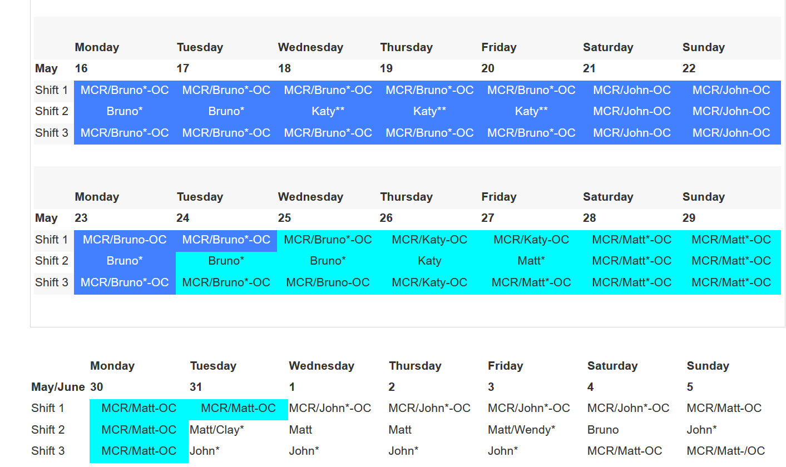
Vacation/DORs:

Steve Bogdan – 5/16 - 5/22 Telecommute
Shane Flood - 5/16-5/20 Travel/Workshop
Matt Spilker-5/16 Telecommute
Bruno Fieramosca – 5/19 DOR
Ashley Wayman - 5/20 DOR
Nena Moonier – 5/17 ½ VAC 5/19 and 5/20 VAC
Liz Schmidt - 5/20 FH

Storage ring closes 5/18
- If you are Job Coordinator on FE CCWPs check on work
  - If completed route for validations complete
  - All FE CCWPS need to be through validations complete by Wed at noon.
  - When CCWPs are removed from cabinets and logged please update the last column on the spreadsheet.
- Pre Run Checklist
    - CCCL and QEW walkthrough
      - Tim Smith for help. Tim is available 5/18, 5/23, 5/25, 5/26, 5/27
      - 438 and help with 431
    - Commissioning ESAFs
    - CCWPS
    - Type C List
    - Review AR
- Feedback from May Power Outage
  - No lost equipment or problems reported
  - Project post-mortem still to be scheduled by Doktorczyk

Round Table Discussion

Nena
- Covid guidance
  - See Argonne Today/emails for new guidance and notes from 3/7
  - Updated APS web info: https://www.aps.anl.gov/Users-Information/Updates/Covid-Rule-Regulations
- ESAF rules for submission and approval:
  - Starting 2022-2 run will allow 5 onsite non ANL users per ESAF.
- Guest House will be opening up May 16 in time for summer students. 401 Grill will expand their menu to include items from 2 years ago.
- The Shoe-mobile is returning to regular site visits. Starting next week, it will be in the 200-203 area parking lot Mondays from 0800 to 1200.
- QEW Practical Exams are no longer available in TMS. They must now be scheduled as needed through Cari Helberg, currently the only SME giving exams.
- Starting 4/25/22 Mike Wachel will take over for Caroline Fisher-Haase as the APS waste specialist. Mike Wachel, Office: 437 D008, Email: mwachel@anl.gov, Desk Phone: 2-6682
- IT Group contacts for beamline support:
Linux -- Fred Carter, Tom Naughton, Troy Lutes
Windows -- Zac Bastile, Dan DeVito, Steve Potempa
Mac -- Fanping Zhu, Jon Smejkal
Liz
- Fully approved 2022-2 commissioning ESAFs can be posted starting today (5/16). Run dates for 2022-2 are 5/31/22 to 9/30/22.
- IMCA-CAT is next on the schedule for TYSSR. They are due in June 2022. Will schedule the review soon.
Bruce
- Request to modify ESAF handling of Mail-in users is completed and moved to production.
- Request to update ESAF expired training email to include users with expired training in TO: list is completed and moved to production.
Katy
- Nothing further to add
- Katy will do all Pre Run activities for 431 including CCCLs and QEW.
- Going forward.
  - Sector 1 &2 Wendy/Steve. Sector 3&4 Bruno
  - Eye washes-Bruno
  - LSI from June onward-Bruno
Bruno
- Need revisit rerouting of gas cabinet lines at Sector 5. Need to work this out with Andy Stevens.
- Common ODH monitor in alarm due to LN2 venting: 10ID-A, 21ID-D, 4ID-B
- 435 truck lock: ODH monitor has been received and is Bruno’s office and Andy has been notified
- ESH436 PR can be used for outside contractors as per Mike Fries. Bruno will schedule sessions with Jeff Collins people soon.
- 4 portable O₂ monitors out. Keep a look out: 1BMB, 4IDD, 20IDA, 25IDB
- Shutdown Work in 432 Area:
  - Validation of PSS yoko transmitters in 1-12 (Matt JC)(Shane FC)
  - Service Gravity Feeds for 6-ID, 7BM and 11BM (Not RSS)
- Shared computer monitor in Bruno’s office is no longer working: Shane to get a new one.
- Started CCCLs today (5/16)
Clay
- Construction of Sector 8 & 9 on schedule for Fall: kickoff meeting tomorrow morning at 1100
  - Operations will be affected in 8-BM and 9-BM
  - 8-BM may not be an active beamline
  - 9-BM C inboard door-sealing door shut
- Bionanoprobe (9ID) to 2-ID: possibly in Aug. Beam in mid Sept.
- Shutdown work in 433 on schedule for completion
  - Validation of PSS yoko transmitters in 1-12 (Matt JC)(Shane FC) -- this week
  - Calibrate FEEPS Yokos 9-16 (Matt JC)(Shane FC) -- this week
  - Service Gravity Feeds for 6-ID, 7BM and 11BM (Not RSS)
- Future work: Grinding SR wall at 11-BM-A to accommodate moving their mono 3 inches inboard; shielding studies on going this time
John
- Shutdown work in 434
  - Shutter work at 14-ID (SS1 is done and routed in ICMS and 14-IDC is scheduled for next week) and 16BM. (Clay is JC, John as FC)
  - 13-ID PSS validation
  - FERDP Swap at 16-BM
  - 16-BM BLEPS upgrade and 16BM BLEPS solenoid upgrade (not RSS)
  - Calibrate FEEPS Yokos 9-16 (Matt JC)(Shane FC) -- this week
  - PSS FERDP Wiring verification, Sectors 16-35 (Ashley is JC, John as FC)
- Oxygen monitors are being calibrated now
- Routine Rad surveys will be scheduled. Need backup
Matt
- USAXS move to 20ID to commission enhancement still set for the Fall: Working with Shelly Kelly for move
- HEXM hutches for LBB
  - Caratelli will be onsite next week to start work on HEXM enclosures
- Shutdown work in 435
  - 18-ID BLEPS solenoid upgrade (non RSS)
  - FERDP wiring verification Sectors 16-35 (Ashley as JC, John as FC)
  - BM FE PS1/PS2 switch replacement (Clay JC) John FC
  - SS switch replacement on BM FE (Clay JC) (John FC)
- POC for He recovery work
Ashley
- Working on getting 436B rekeyed
- Working on 436 Gas Cage move
- Shutdown Work in 436
  - Floor Grinding Done
  - 34BM wrapping up
- Caratelli hopefully onsite next week to start work on the HEXM enclosure
Shane
- 437 build out essentially complete. Punchlist items ongoing.
- 25-ID
  - Started construction of laser enclosure. Mostly built out. Utilities ongoing
  - Laser room enclosure (end of 25-ID beamlines) contract awarded to Scheck. Scheck initiating ductwork and mechanical installation for enclosure today.
  - Shielding verification on 25ID-A- still ongoing.
- 28-ID Be window swap: 1 for 1 swap in review with Patti’s group.
- 30ID and 5ID JSA/WPC for Kohzu completed.
- 26-ID FBM Oxford JSA/WPC completed.
- Shutdown work in 437
  - FERDP wiring verification Sectors 16-35 (Ashley as JC, John as FC)
  - PSS Validation for 28-ID
Steve
- Steve is currently scheduling DEEIs but Nena and Liz are on standby and will help if needed.
- Wendy will complete the eyewash/LSI inspections.
- Wendy will follow up on beamline requests for 438.
- Shutdown Work in 438
  - FERDP wiring verification Sectors 16-35 (Ashley as JC)
  - 34BM FE Removal (Ashley as JC)
Wendy
- 31ID: Irelec (contractor) onsite 5/31-6/2 for robot work for LRL-CAT. Work will be done in the APS clean room. They will call 2-0101, paperwork on Steve’s door.
- 35ID: Sydor (contractor) onsite 5/31-6/2 for detector work in 35-ID-B and 35-ID-E. They will call 2-0101, paperwork on Steve’s door.
- Plan to assume 438 FC roles- will take over eyewashes and life safety inspections.

