Present: Nena, Liz, Katy, John, Matt, Ashley, Wendy, Steve, Bruce, Bruno, Shane

EFOG Presence onsite: 3/21/2022-4/3/2022
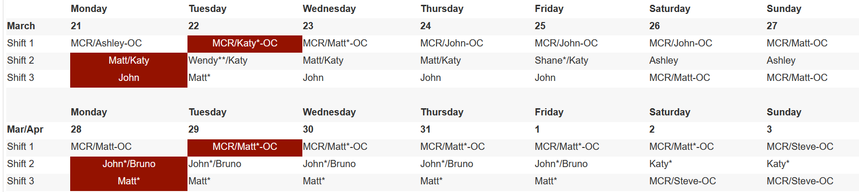

Vacation/DORs:
Nena Moonier-3/21/22 ½ MA
John Mazzio- 3/22 DOR
Ashley Wayman-3/25 DOR
Wendy VanWingeren-3/25 VAC
Steve Bogdan-Sick Leave

Next Week:
Ashley Wayman-3/28 DOR
Steve Bogdan-3/28-4/1
Wendy VanWingeren-3/28 -4/1
Shane Flood-3/28-4/1
Steve Bogdan-Sick Leave

Presentation/Discussion Topics:

Ongoing Notes:

- Tornado Shelter drill April 5 at 10am. Post meeting TBD
- The Shoe-mobile is returning to regular site visits. Starting next week, it will be in the 200-203 area parking lot Mondays from 0800 to 1200
- QEW Practical Exams are no longer available in TMS. They must now be scheduled as needed through the individual electrical safety SMEs-Work with Cassandra Hayden
- 401 Grill opening up 3/28 limited hours. 11am to 1:30pm. Monday to Friday.
- 213 Café open as well.

Events to Report:
- 12ID-C shutter issue-Investigation into Fail to fully open/No switch warnings found that a bolt on the air cylinder was too long and catching on another bolt on the assembly. Shutter is slated for repair during May shutdown.
- 7BM 911 call. Small fire contained in steel box; no damage to hutch or equipment
- 6ID-Solenoid Replacement. Finished 3/21 morning.
- 14ID C shutter – ongoing issue. Non-standard build for APS shutters. Fix is to set air pressure to maximum for now.
- 438 911 call – odor 437 hallway – paint odor in area

Shutdown Planning Notes:
- Tunnels open April 29th. Close date is currently May 18th, but may change. Despite COVID restrictions loosening in general, access to the MCR will remain limited.
- New BLEPS will be installed at 16BM and 23BM
- BLEPS will be modified at 18BM, and possibly 26ID
- The 34BM FE will be removed by APS-U, beginning early in the shutdown
- The 27ID FE Exit Table will be swapped for the upgraded design, as a pilot test for a facility-wide project at the start of the dark period
- APS-U will swap out a mirror at 26ID
- 1ID’s ladder will be replaced by a staircase. This is deferred work from previous shutdowns
- LN2 decks will be installed at 4ID, 19ID, and 20ID
- Repairs or rebuilds are scheduled for the following shutters: 12ID-C, 14ID SS1, and 14ID-C

APS May Power Shutdown Notes:
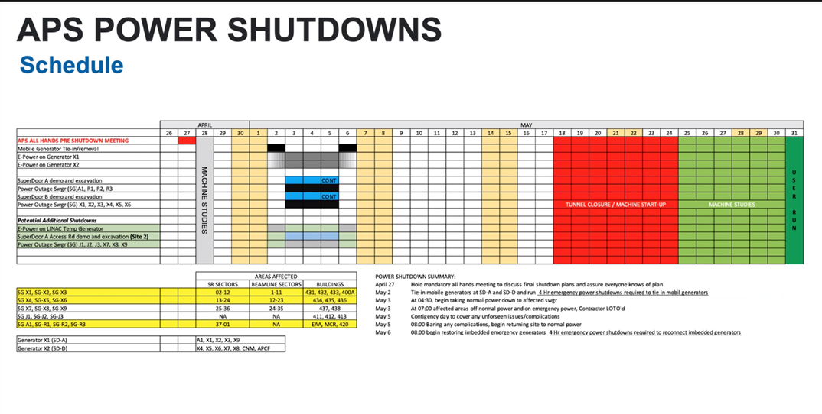
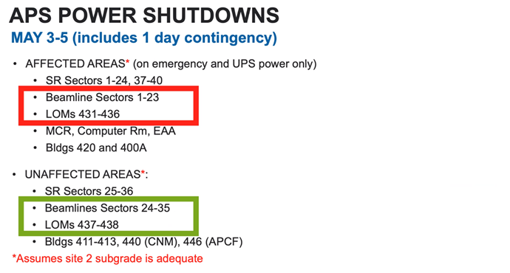
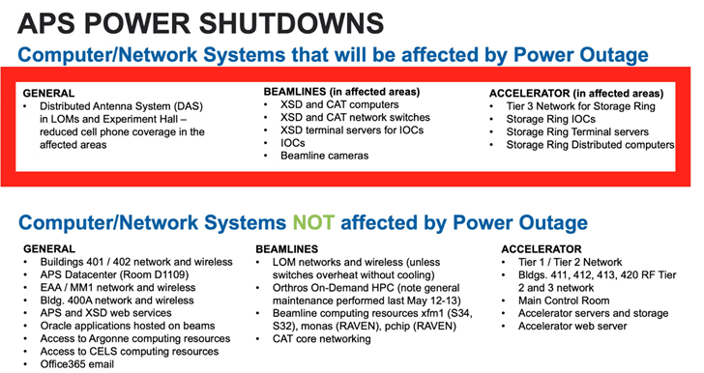
- FCs to work with beamlines for locations of cord drops. Please contact each of the affected beamlines and walk the area with them. Post it notes are the best to pinpoint locations. Locations should be done by COB on April 15.

Experiments of Note:

3/21/2022 - 3/28/2022

- ESAF 253394 at 1-ID-E. Onsite user from ANL (NM). 03/22/22 - 03/25/22. Radioactive Samples
- ESAF 252170 at 35-ID-C. Onsite users from LLNL. 03/21/22 - 03/24/22. Explosive Samples

Round Table Discussion

Nena
- New Covid guidance
  - See Argonne Today/emails for new guidance and notes from 3/7
- ESAF rules for submission and approval:
  - Starting Feb 28, 2022
    - 3 onsite users allowed per ESAF (total includes both external users and ANL users from divisions outside of PSC (MSD, ES, CSE, etc.)) Onsite access request form (upper management approval) needed only for ESAFs in which 4 or more users are requesting onsite access
    - ESAFs with non ANL onsite users require 14 day submission, ESAF with remote/Mail or ANL onsite users require 7 day submission
- Restart plan set for Feb 28, 2022 with full implementation on March 14, 2022
  - EFOG restart plan (effective 2/28/2022)
    - Everyone to be onsite every day.
    - Normal onsite hours 8:30 to 5pm: Core hours: TBD
    - Shifts
      - Dayshift: 8am to 4pm
      - Evening: 2pm to 10pm
      - Weekend: 8am to 6pm
      - Shift exchange at 3pm
    - Any change in normal hours stated above must be discussed and approved by GL.
    - Advance notice for telework option - Telework examples: online workshops, conferences, training. Telework not allowed unless approved in advance.
Liz
- LS-CAT (Sector 21) TYSSR: Thursday, April 14, 2022 at 1pm on Teams
Matt
- On Wednesday (3/23) IH will be conducting a noise survey in the 435 courtyard, still waiting on management to decide on the official use of the space in the future. ODH testing already completed.
Bruce
- All COVID19 information removed from ESAF and ESAF report. Code was commented out in case it needs to be reinstated.
- ShiftLog Post ESAF error corrected. Equipment information is now being copied to Experiments db.
- Experiments db updated to include all Equipment information since 3/14/2015.
- Submitted vector request to update esaf expired training email to include users with expired training in TO: list.
- Looking at ESAFs.
Shane
- 437 buildout project essentially complete. Punchlist items ongoing.
- 25ID
  - Axilon work scheduled for April. Installation team from Germany will come to ANL for work
  - Laser room enclosure (end of 25-ID beamlines) contract awarded to Scheck. Scheck initiating ductwork and mechanical installation for enclosure today.
  - FMB mirror installation in the FOE complete as of Friday.
  - Shielding mitigation is still an open item. Further mitigation parts have yet to be installed.
Katy
- Nothing of note
Bruno
- Need revisit rerouting of gas cabinet lines at Sector 5. Need to work this out with Andy Stevens.
- Common ODH monitor in alarm due to LN2 venting: 10ID-A, 21ID-D, 4ID-B
- ESH436PR needs to be scheduled for Matt: Scheduled for 3/23
- 435 truck lock: ODH monitor should arrive end of this month
- Follow up ESH436 PR is this required for outside contractors? Shane/Bruno to follow up with Paul and Mike
John
- Follow up re: 14-ID-C shutter
Steve
- Follow up on DEEI for ESAF 253319 (may require QEW1)
Ashley
- LBB-Talked with Steve Hunsberger about power/e-power. Will forward May power shutdown schedule to him once finalized.
Clay
- APS power shutdown May 2 – 6. Tentative Plan is to come up on May 6th.
Wendy
- Nothing to report

