Present: Nena, Bruce, Wendy, Ashley, Clay, Liz, Steve, Bruno, Katy, John

EFOG Presence onsite: 3/14/2022-3/27/2022
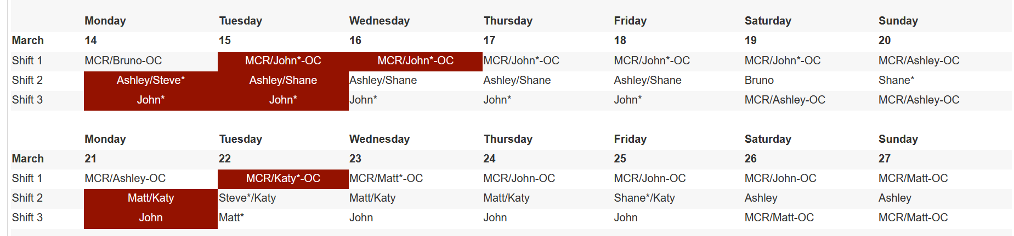
Vacation/DORs:
Nena Moonier-3/14/22 SLF
Matt Spilker-3/14-3/18 Vac
Shane Flood-3/14 SLF

Presentation/Discussion Topics:
- Change in FC1/FC2 Phone & Shift Turnover with MCR: Return to Pre-Covid Plan
  - FC1 phone carried by dayshift FC1, passed to 2-10pm FC, FC1 phone delivered to MCR at 10pm during the week. (Weekend FC picks up and drops at MCR)
  - Email turnover should still be sent to asdops, please also provide a PRINTED TURNOVER to the MCR when FC1 is dropped off.
  - FC2 phone stays in the possession of EFOG, shift remains 8am-2:30pm during the week. FC2 on Friday to deliver phone to the next scheduled FC2 (or leave charging inside incoming FC2’s office).

Ongoing Work:

- 25ID – TBD on next shielding mitigation tests. Shielding issues remain, further mitigation is yet to be installed.
- LBB – finishing up final details;
- 437 LOM – nearly complete. Only small items on punch list
- May Power shutdown- Clay to report
- Tornado Shelter drill April 5 at 10am
- Shutdown Planning meetings set to start Wednesday 3/16

Events to Report:

- Sector 24 beamline stability issues and access to beam steering form/stability questionnaire. Per Operations, the instability was due to changes made by L. Emery during studies. He had forgot to remove them before user ops.
- 12ID-C shutter warnings being looked into by MOM-VAC 3/15

Experiments of Note:

3/14/2022 - 3/21/2022

- ESAF 252511 at 1-ID-E. Onsite user from LANL. 03/16/22 - 03/21/22. Radioactive Samples
- ESAF 251663 at 16-ID-D. Onsite users from LLNL. 03/16/22 - 03/20/22. Radioactive Samples
- ESAF 252309 at 7-BM-B. Onsite users from ARL. 03/16/22 - 03/19/22. Explosive Samples
- ESAF 252560 at 16-ID-B. Onsite users from LLNL. 03/18/22 - 03/21/22. Explosive Samples
- ESAF 252170 at 35-ID-C. Onsite users from LLNL. 03/21/22 - 03/24/22. Explosive Samples

Round Table Discussion

Nena
- New Covid guidance
  - Vaccines remain mandatory for employees, in keeping with LMS-POL-84: COVID-19 Vaccination Policy as already enacted. Booster shots are recommended.
  - There are no additional site-access requirements (such as proof of negative test results) for visitors or employees with vaccine exemptions.
  - Site-access requirements for users at the APS and other user facilities remain in place (proof of vaccination or negative test within 72 hours).
  - Face coverings are no longer required, regardless of vaccination status, except in the Health and Employee Wellness (HEW) clinic and in small, enclosed spaces when it is not possible to maintain a distance of at least 3 feet from others (e.g. elevators, government vehicles).
  - Social distancing is optional, regardless of vaccination status.
  - The screening program is suspended, though diagnostic testing and testing for international business travel remain available through HEW.
  - The wearable proximity device program is suspended. (Look for information in the coming weeks on how to return currently distributed devices.)
  - Gatherings remain limited to 50 or fewer people.
  - Vaccinated individuals can travel domestically and internationally. Unvaccinated individuals may travel only after mission-critical travel requests are approved.
  - Employees must continue to perform the daily self-check before entering the Lab, and must promptly report symptoms, positive test results, and close contacts to the COVID-19 Question Line at 630-252-2555. Employees must quarantine or isolate as directed.
  - The Lab will sustain augmented flow and filtration for building ventilation, enhanced surface cleaning and disinfection, and contact tracing
- ESAF rules for submission and approval:
  - Starting Feb 28, 2022
    - 3 onsite users allowed per ESAF (total includes both external users and ANL users from divisions outside of PSC (MSD, ES, CSE, etc.))
    - Onsite access request form (upper management approval) needed only for ESAFs in which 4 or more users are requesting onsite access
- Restart plan set for Feb 28, 2022 with full implementation on March 14, 2022
  - EFOG restart plan (effective 2/28/2022)
    - Everyone to be onsite every day.
    - Normal onsite hours 8:30 to 5pm: Core hours: TBD
    - Shifts
      - Dayshift: 8am to 4pm
      - Evening: 2pm to 10pm
      - Weekend: 8am to 6pm
      - Shift exchange at 3pm
    - Any change in normal hours stated above must be discussed and approved by GL.
    - Advance notice for telework option - Telework examples: online workshops, conferences, training. Telework not allowed unless approved in advance.

Liz
- LS-CAT (Sector 21) TYSSR: Thursday, April 14, 2022 at 1pm on Teams
Matt
- On vacation this week
Bruce
- Met with Arvind, Jennifer, and Liz to discuss esaf copy to experiments db. Put in two vector requests: 1) identify problem is shiftlog when esaf info is improperly copied to experiments; 2) update experiments db records beginning from 3/14/2015
- Submitted vector request to update esaf expired training email to include users with expired training in TO: list.
- Identified where covid information is in esaf and the esaf report. Hopefully, we will get to remove this info soon.
- Looking at ESAFs.
Shane
- 437 buildout project essentially complete. Punchlist items ongoing.
- 25ID
  - Axilon work scheduled for April. Installation team from Germany will come to ANL for work
  - Laser room enclosure (end of 25-ID beamlines) contract awarded to Scheck. Scheck initiating ductwork and mechanical installation for enclosure today.
  - FMB mirror installation in the FOE complete as of Friday.
  - Shielding mitigation is still an open item. Further mitigation parts have yet to be installed.
Katy
- Nothing of note
Bruno
- Need revisit rerouting of gas cabinet lines at Sector 5. Need to work this out with Andy Stevens.
- Common ODH monitor in alarm due to LN2 venting: 10ID-A, 21ID-D, 4ID-B
John
- Few routine rads this week. See the schedule on the web.
Steve
- The operations proposed permanent steering change at 35ID has been deferred until the beginning of next run.
Ashley
- Nothing to report
Clay
- APS power shutdown May 2 – 6. Tentative Plan is to come up on May 6th.
Wendy
- Nothing to report

