Present: Wendy, Liz, Steve, Bruno, Shane, Katy, John, Matt, Ashley, Clay, Bruce
,
EFOG Presence onsite: 3/7/22-3/20/22
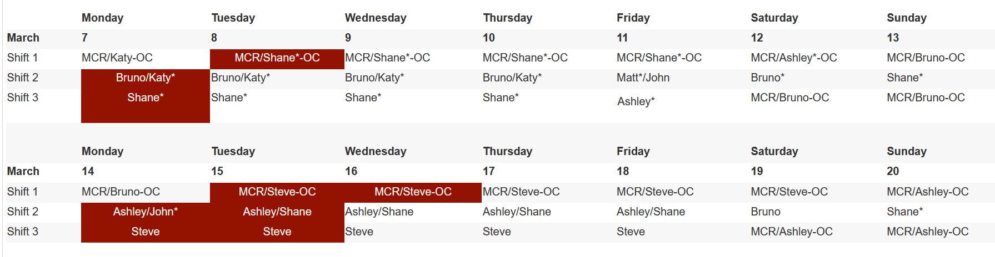
Vacation/DORs:

John Mazzio 3/8 - 3/10
Shane Flood 3/11

Presentation/Discussion Topics:
- Ashley and Katy to present the Hutch Welding Request Form (APS_2185611)
- Change in FC1/FC2 Phone & Shift Turnover with MCR: Return to Pre-Covid Plan
  - FC1 phone carried by dayshift FC1, passed to 2-10pm FC, FC1 phone delivered to MCR at 10pm during the week. (Weekend FC picks up and drops at MCR)
  - Email turnover should still be sent to asdops, please also provide a PRINTED TURNOVER to the MCR when FC1 is dropped off.
  - FC2 phone stays in the possession of EFOG, shift remains 8am-2:30pm during the week. FC2 on Friday to deliver phone to the next scheduled FC2 (or leave charging inside incoming FC2’s office).

Ongoing Work:

- 25ID – TBD on next shielding mitigation tests. Still some issues
- LBB – finishing up final details; 436 parking lot is now open; not changing FedEx pick up points or gas yard until the next shutdown
- 437 LOM – nearly complete. Only small items on punch list

Events to Report:

- Mod C connection was successful and uneventful. Mod C provides LNDS for 18-27.
- 8-ID-I hutch door bearings replaced on 2/28. Done and uneventful.
- 13-ID has been experiencing beam stability issues since Feb. 13th
  - Feb 18th: Received page from BL staff, had them fill out beam stability questionnaire and contacted MCR, BL and MCR couldn’t find any issues on their ends, MCR calls storage ring manager and physicist.
  - Feb 19th : MCR tells BL staff they did improvements, beam is better
  - Feb 20th : Experiencing issues again, BL staff will check again on Tuesday (2/22)
  - Follow-up needed?
- 16-ID has been having issues over the last week and a half and Randy did not find anything and has passed information on to Louis.
  - Follow-up needed?
- 24ID experienced a FEEPS fault on 3/7 at 1216 resulting in stored beam loss. SI performed 1-1 swap of PSS power supply later that morning during machine studies. 24-ID back online now. (Chain A power supply)

Experiments of Note:

3/7/2022 - 3/14/2022

- ESAF 252362 at 10-ID-B. Onsite user from BIO. 03/09/22 - 03/14/22. Radioactive Samples
- ESAF 252228 at 16-ID-D. Onsite users from LLNL. 03/11/22 - 03/14/22. Radioactive Samples
- ESAF 252977 at 16-BM-D. Onsite users from LANL. 03/11/22 - 03/14/22. Radioactive Samples

Round Table Discussion

Nena
- New Covid guidance will be coming soon. Awaiting DOE approval before it can be implemented. Will be a reduction on covid controls.
- Covid weekly testing. Please make sure you schedule and test weekly. Absences are noted and sent to supervisor. Roughly 1400 people are registered for covid testing.
- APS has purchased KN95 masks and are in the stockroom. Current masks are still viable but this is another option.
- ESAF rules for submission and approval:
  - Starting Feb 28, 2022
    - 3 onsite users allowed per ESAF (total includes both external users and ANL users from divisions outside of PSC (MSD, ES, CSE, etc.))
    - Onsite access request form (upper management approval) needed only for ESAFs in which 4 or more users are requesting onsite access
- Restart plan set for Feb 28, 2022 with full implementation on March 14, 2022
  - Hybrid work plan: Please submit Request for Flexible Work Arrangement in Workday
  - EFOG restart plan (effective 2/28/2022)
    - Everyone to be onsite every day.
    - Normal onsite hours 8:30 to 5pm: Core hours: TBD
    - Shifts
      - Dayshift: 8am to 4pm
      - Evening: 2pm to 10pm
      - Weekend: 8am to 6pm
      - Shift exchange at 3pm
    - Any change in normal hours stated above must be discussed and approved by GL.
    - Advance notice for telework option - Telework examples: online workshops, conferences, training. Telework not allowed unless approved in advance.

Liz
- XSD-IMG (2-BM, 7-BM, 32-ID) TYSSR: Wednesday, March 9, 2022 at 11am on Teams
Matt
- 435 Truck Lock courtyard LN2 system to be tested on Wednesday @ 8am.
- Contractor from Cytiva will be at Sector 18 to update software and firmware for Autosampler system on Tuesday (Tomorrow)
Bruce
- Submitted a request on 1/24/22 to make sure that the ESAF (with RGD update) gets copied properly to Experiments when posted in shiftlog. We found an issue with copying equipment info into the Experiments db. I have identified the date when this occurred and think I have a solution. We will need a meeting with Arvind and Jennifer.
- Nena setup a meeting at 1300 Thursday, 3/10/22.
- Looking at ESAFs.
Shane
- 437 buildout project essentially complete. Small punch list items remain.
- 25ID
  - Axilon work scheduled for April. Contractor will be coming onsite from Germany.
  - Laser room enclosure (end of 25-ID beamlines) contract awarded to Scheck. Late March start date.
  - FMB is still scheduled for late Feb early March. This includes second mirror tank install and optics install.
  - Shielding mitigation is still an open item. Robert Winarski is still waiting on fabrication of parts. Shops told him completion date of 3/1 for the parts.
Katy
- Nothing of note
Bruno
- 21st and 22nd of February 8-ID detector maintenance
- Need revisit rerouting of gas cabinet lines at Sector 5. Need to work this out with Andy Stevens.
- Common ODH monitor in alarm due to LN2 venting: 10ID-A, 21ID-D, 4ID-B
John
- Few routine rads this week. See the schedule on the web.
Steve
- Global Controls visit for 35ID set for 3/14; JSA/WPC on 438 door.
Ashley
- 436 parking lot is open. FedEx pick up and gas cages won’t be moved until after this run.
- Check the badge drop offs in your areas. I’m out of prox cards to give out.
Clay
- Nothing to report

