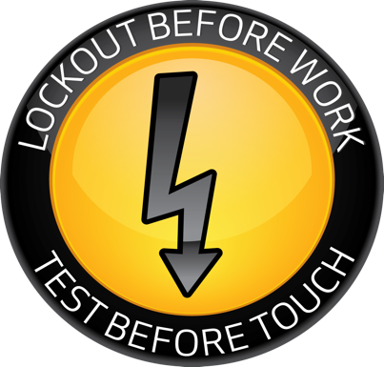 | Electrical Safety Field Observation Guide |  |  |  | 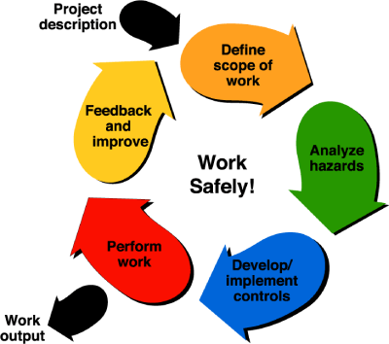
Safety Observer |  |  |  | Date
Job/Task Observed
This Observation Guide is to help direct the activities of the Observer, NOT to direct the work itself.
Sections 10, 13, 15, and 17 are mandatory observations.
All other sections of this “Observation Guider” are at the discretion of the observer.
Electrical Safety Touchpoints |  |  | Safety Observer Notes
PART 1: DAILY PPE INSPECTION
- Voltage Glove Inspection  - Properly stored upon arrival  - Voltage class (max usage and max test) and type  - Inspection date and serial number  - Visual inspection inside and out  - Glove inflation test  - Leather glove inspection  - Cotton liner inspection |  |  | - Rubber stored with cuffs down in bag  - Class (00) 500vac-750vdc, (0) 1kvac-1.5kvdc, (1) 7.5kvac-11.25kvdc, (2) 17kvac-25.5kvdc, (3) 26.5kac-39,75kvdc, (4) 36kvac-54kvdc  - 6-month period of use; retest after 6 months  - Reference Electrical Safety Manual (ESM) Chapter 7 & 17
- Voltage Meter & Tools Inspection  - Category rating  - Inspection of leads  - Inspection of meter  - Test meter fuses  - Perform live test of meter  - Understand meter indications  - Verify rating of insulated tools  - Check physical condition of insulated tools |  |  | - Look for NRTL and double-insulating symbols.  - Verify Category Rating III or IV.  - Visually inspect the leads for damaged insulation, and the case for cracks and damage.  Certain meters have the capability to check the internal fuse when reading amps. Check fuse condition by following:  - Set meter to Ω.  - Plug lead into the V port and insert in the A port. Reading should be near 0.  - If there is an mA port, insert the lead. Reading should be near 10k.  - An OL reading in either case indicates a blown fuse.
- Arc Flash PPE Inspection  - ATPV or Ebt Rating  - Condition of clothing  - Condition of faceshield/hood  - Condition/Rating of hard hat  - Safety Glasses  - Boots  - Hearing Protection |  |  | - Inspect arc flash PPE before each use.  - Look for damage such as rips, cuts, abrasion, scratches, cracks, and perforations.  - Verify rating of hard hat E rated 20kv. G rated is general use 2.2kv rated.  - Canal insert for hearing protection.

Electrical Safety Touchpoints |  | Safety Observer Notes
PART 2: JOB PLANNING
- ISM  - Explain the 5 steps of ISM  - Fully describe scope of work to be accomplished  - Describe basic event sequence, start to finish  - Modes of work necessary for this project |  | - Develop Scope  - Analyze Hazards  - Develop Controls & Implement  - Perform Work  - Feedback/Improvements
- Switching Rules:  - Conditions for normal operation:  - The equipment is properly installed  - The equipment is properly maintained  - All covers are in place and secured  - There is no evidence of impending failure  - Labeled with AF hazard |  | The worker will take the following standard precautions:  - Stand to the side. Where possible, do not reach across panel to the switch handle, but stand on the same side as the switch handle.  - Place hand on the switch handle but do not operate.  - Face away from switch, close eyes, take a deep breath and hold it.  - Forcefully throw the switch in a complete full motion.  - Verify system response.  Minimum PPE for non-hazardous switching: leather glove on the switching hand and safety glasses.  Non-hazardous switching is switching with no shock or arc flash hazard, and the conditions for normal operation are satisfied.
- Shock Hazard Analysis  - Determine/explain shock exposure  - Determine/explain nominal voltage of exposed parts  - Determine/explain shock protection boundaries  - Determine/explain appropriate shock protection PPE level |  | Shock hazard: if you can accidentally touch or walk up to any exposed energized parts that are not enclosed, guarded, or insulated.  Shock protection boundaries apply to exposed energized parts and are defined by the equipment voltage of 50v and greater.  Limited Approach Boundary:  - Non-QEWs stay out unless escorted by QEW.  - Insulated tools required.  - LOTO required.  Restricted Approach Boundary:  - Restricted to QEW ONLY.  - Shock PPE required for all parts of the body.  See Table on last page.
- Arc Flash Hazard Analysis  - Determine/explain arc flash exposure (from AF Label)  - Determine/explain incident energy and working distance (from AF Label)  - Determine/explain arc flash boundary (reference NFPA 70E for AF boundaries)  - Determine/explain appropriate arc flash PPE level boundary (reference NFPA 70E PPE Levels 0-4)  PPE levels: 0 = > 1.2 cal/cm2;  1 = 4 cal/cm2; 2= 8 cal/cm2;  3 = 25 cal/cm2; 4 = 40 cal/cm2 |  | The following activities do NOT create an arc flash hazard:  - Reading a panel meter while operating a switch.  - Work on control circuits with exposed energized parts, 120 VAC or below including opening of covers.  - Insulated cable examination with no manipulation.  - DC systems, insertion or removal of individual cells or multi-cell units of a battery system in open racks.  - Removal or installation of covers for wireways, junction boxes, cable trays and similar equipment, that does not expose bare energized parts.  - Application of temporary protective grounding equipment after Zero Voltage Verification (ZVV).  Establish barricades outside of the Arc Flash Boundary (or the Limited Approach Boundary, whichever is greater) found on the arc flash label.
- Control of Work:  - Simple LOTO conditions  - Two-person rule requirements  - Alerting techniques (signs, barricades, attendants) |  | - See the Electrical Safety Manual (ESM) Chapter 3 ‘Electrical Hazard Classification’
- Emergency Response:
- Steps for emergency response
- Location of emergency disconnect
- Unobstructed access/egress
- Location of phone or pull station

Electrical Safety Touchpoints |  | Safety Observer Notes
PART 3: JOB EXECUTION
- On the Job Briefing  Scope of Work  Hazards  Controls |  | Discuss scope of work, ask questions on operation. Hazards addressed. Control mitigation process. All workers must understand and agree on the tasks.
- Barricades
- Set up signs and barricades as needed
- LOTO Notification
- Notify affected persons
- Donning PPE  Proper donning of PPE  All PPE correct  Removal of conductive articles  Non-insulated tools stay outside of RAB |  | Verify AF hazard and PPE requirements with AF label on equipment.  See Sections 1 and 3 for additional observations on checking condition and rating of PPE.
- Switching  - Proper body positioning  - Proper PPE  - Take a deep breath and hold  - Forceful throw  - Verify system response |  | Reference Electrical Safety Manual (ESM) Chapter 5.15
- LOTO Application  Apply and challenge LOTO Lock  Proper use of LOTO tag and lock  Challenge the LOTO  Perform a start test |  | Reference ESH 7.1
- Opening and Inspection:
- Stand to side and open equipment enclosure
- Visually inspect inside
- Look for impending signs of failure
- Zero Voltage Verification:
Check meter on known energized source
Verify zero voltage on all applicable combos:
Phase to ground
Phase to neutral
Neutral to ground
Phase to phase
All exposed parts to be touched
Check meter on known energized source
- Stored Hazardous Energy Dissipation:
- Follow specific steps in written Complex LOTO Procedure to dissipate stored hazardous energy
Proceed with work ------ Complete Work |  | Not Assessed

Electrical Safety Touchpoints |  | Safety Observer Notes
PART 4: JOB CLOSEOUT
- Confirm it is safe to re-energize
- Equipment is in a safe condition
- Employees are in a safe position
- Restore power:
- Notify affected persons
- Re-energize using proper switching technique
- Feedback to/from Safety Observer
- Discuss what went well/what needs improvement

Overall Safety Observer Comments:

Upon completion, return this form to electricalsafety@anl.gov

